w

AI 894: Design & Implementation of AI Systems

Biomarker Candidate Discovery and ranking Using AI-assisted Evidence Synthesis

Team 3
Ayan Choudhury & Keith Coughlin & Gabriel Saenz

Master of Artificial Intelligence (AI)
SP 2026

Instructor: Youakim Badr, Ph.D.

Document Control

Work carried out by:

Members | Email Address
Ayan Choudhury | azc6461@psu.edu
Keith Coughlin | kac7102@psu.edu
Gabriel Saenz | gas5727@psu.edu

Revision Sheet of Contributions

Release No. | Date | Member | Revision Description
1.0 | 1/23/2026 | K. Coughlin | - Document set-up  - First draft of sections 1-4
1.1 | 1/24/2026 | G. Saenz | - Formatting and general cleanup from template  - Add some background info to the challenges section  - Started Feasibility Studies Section with 6 relevant Journals  - Define Required Technologies  - Outline Deliverables section
1.2 | 1/25/2026 | A. Choudhury | - Added context and streamlined data throughout the document.
1.3 | 1/25/2026 | K. Coughlin | - Completed week 2 deliverables, ready for final review.
1.4 | 2/14/2026 | K. Coughlin | - Completed build of omics pathway and scoring module  - Completed statistical python notebook for omics pathway
1.5 | 2/22/2026 | All | - Completed end to end testing of MVP  - Determined path forward to enhance process
1.6 | 3/29/2026 | Gabriel Saenz | - Outlined cloud architecture and deployment strategy

Table of Contents
Document Control 1
Work carried out by: 1
Revision Sheet of Contributions 1
Project Proposal 5
Project title 5
Keywords: 5
Background and Challenges 5
Business and Financial Challenges 6
Data Challenges 7
AI Algorithms and Methods Challenges 7
Infrastructure Challenges 7
AI Ethics Challenges 7
Privacy and Cybersecurity Challenges 7
Project Objectives 7
Feasibility Studies 8
How this project differs from existing research 10
Methodology (AI System) 10
Workflow and Pipeline 10
Planned Tasks 11
Deliverables 12
Importance and Impacts 13
Project Schedule 14
Required Technologies 15
Programming Languages 15
Web Interface 15
Misc technologies 15
Lesson 4 AI system Design and Infrastructure 16
System Requirements 16
Functional Requirements 16
Data Ingestion 16
Data Processing 17
Evidence Extraction and Integration 18
Evidence Scoring and Ranking 19
Biomarker Classification and Predictive Modeling 19
Ablation and Signal Contribution Analysis 20
Data Visualization and Reporting 21
Logging and Monitoring 22
Model Updating and Re-execution 22
Non-Functional Requirements Performance 22
Scalability 23
Availability 23
Reliability 24
Security 24
Maintainability 24
Ethics and Safety Requirements 25
Responsible Use 25
Fairness 25
Transparency and Explainability 25
Privacy 25
Part 2: Infrastructure Plan 26
Compute Infrastructure 26
Data Infrastructure 26
API and External Services 26
Application Infrastructure 27
Security Infrastructure 27
CI/CD and Version Control 27
Monitoring and Logging 27
Infrastructure Costs 27
Team Responsibilities 28
Lesson 6 Data preprocessing and AI Planning 29
Data Collection 29
Data Sources 29
Data Source Links 29
Tools Used for Data Collection 30
Data Storage 30
Data Catalog 31
Feature Dictionaries 32
TCGA-COAD.star_counts.tsv (Raw Input) 32
omics_evidence.csv (Differential Expression Output) 32
candidates.csv (Top Candidate Genes) 33
pathway_evidence.csv (Pathway Enrichment) 33
ranked_candidates.csv (Final Scored Output) 34
Data Relevance to Research Problem 34
Data Cleaning and Preprocessing 35
Duplicate Detection and Elimination 35
Missing Value Detection and Handling 35
Data Inconsistency Handling 36
Gene Filtering 36
Statistical Preprocessing 36
Normalization and Standardization 37
Outlier Detection 37
Imbalanced Data 37
Correlation Analysis 38
Data Exploration and Feature Engineering 38
Descriptive Statistics 38
Visualizations 39
Known CRC Gene Validation 39
Feature Construction 40
Feature Selection 40
Feature Transformation 40
Correlation and Interpretation 41
Data Augmentation 41
Model Planning 41
Current Model: Weighted Multi-Evidence Scoring with LLM Analysis 41
LLM-Based Literature Scoring 42
Assumptions and Constraints 43
Future Model Considerations 43
Cost Function 44
Pipeline Workflow 44
Lesson 10 Model Building, TRAINING and Testing 46
Model Validation Strategy 46
Evaluation Metrics 47
Model Validation Results 48
Bias Variance Analysis 49
External Validation Using Known CRC Biomarkers 49
Interpretation of Model Outputs 50
Visualization of Model Results 50
Model Realism and Ongoing Improvements 51
Lesson 12 Model Deployment and Continual Learning 54
Purpose 54
Trained Model Parameters 54
ML Model (Random Forest + SHAP) 54
Random Forest: 54
SHAP Feature Importance 55
Validation accuracy: 55
Continual Learning 55
Caching and Incremental Updates 55
Note on prior approach: 56
Validation as a Feedback Signal 56
ML Approach Iteration: A Case Study in Continual Improvement 57
Deployment Strategy 60
Infrastructure as code 60
CI/CD 60
Deployment Update Cycle 61
Deployment Architecture 61
Serving System: Web Application 63
FastAPI Backend 63
Data Serving Strategy 64
LLM Chat Integration 64
Web UI Features 64
Pipeline Architecture 67
Configuration 68
Pipeline Re-execution Strategy 68
Deliverables Folder Organization 68
Installation and Execution 70
Running the Pipeline 70
Running the Web Application (Local) 71
Deploying to Azure 71
Key Scripts and Notebooks Reference 71
Future Improvements 72
Lesson 12 AI cybersecurity, Ethics and Accountability 73
Purpose 73
AI Cybersecurity 73
Threat Model 73
Credentials and Secrets Management 73
Network Security 74
Application-Level Security 74
LLM-Specific Security 75
Supply Chain Security 76
Known Cybersecurity Limitations 76
AI Ethics and Accountability 77
Responsible Use and Framing 77
Data Ethics and Privacy 77
Transparency and Explainability 78
Bias Considerations 79
Ethical Use of LLMs 79
Version Control and Traceability 80
Performance Accountability via Validation 80
Logging and Monitoring 81
Reproducibility as Accountability 81
Team Accountability 82
Summary 82
Lesson 13 FINAL Report 84
Lesson 14 Project Presentataion & DEMO 86
Appendices 87
Appendix A: Scoring Weight Configuration 87
Appendix B: LLM Scoring Rubric 87
Appendix C: Validation Biomarker Panel (80 markers, 3 tiers) 87
Appendix D: Works Cited 88

Project Proposal

Project title
Explainable AI for Colorectal Cancer Biomarker Evidence Synthesis and Ranking

Keywords:
Natural Language Processing, Generative AI, Explainable AI, Data Analytics, Machine Learning, Healthcare, Life Sciences, Cancer Research, Biomedical Data Analytics

Background and Challenges
Colorectal cancer (CRC) remains a commonly diagnosed disease, with approximately 2 million new cases in 2020 (Sung, Ferlay, & Siegel, 2021). CRC is also a leading cause of cancer death, with nearly 1 million related deaths. Lifestyle and age are strongly associated with CRC risk with few cases attributable with family history (Novielli, Romano, & Magarelli, 2024). Meanwhile, genomic analysis can reveal increased risk for CRC (Marx, 2024). Colonoscopy remains the clinical gold standard for diagnosis; however, it is invasive, costly, and associated with patient discomfort and procedural risks.
As a result, there is growing interest in identifying molecular biomarkers that enable earlier detection, risk stratification, and improved understanding of disease progression. Advances in high-throughput sequencing and bioinformatics have led to the discovery of thousands of potential biomarker candidates derived from transcriptomic, genomic, and microbiome data. At the same time, biomedical literature related to colorectal cancer continues to grow at an exponential rate, making it increasingly difficult for researchers to synthesize existing evidence efficiently.
Colorectal cancer research generates a large volume of biological data and scientific publications each year, leading to the identification of many potential biomarker candidates. Biomarkers are biological signals, such as genes or molecular changes, that may help with early detection or understanding disease progression. However, only a small number of these candidates can realistically be validated due to the high cost and time required for experimental and clinical studies.
In practice, deciding which biomarker candidates should be prioritized is a manual and fragmented process. Researchers often analyze gene expression data separately from the biomedical literature and rely on prior biological knowledge to assess relevance. This makes it difficult to consistently compare candidates and clearly justify prioritization decisions, especially when evidence is spread across many datasets and publications.
Current biomarker prioritization workflows remain largely manual and fragmented, lacking consistency, scalability, and transparency. Evidence supporting candidate relevance is often distributed across heterogeneous datasets and publications, making it difficult to clearly justify prioritization decisions in a reproducible manner.
Key challenges include the rapid growth of unstructured scientific literature, high-dimensional transcriptomic data with limited samples, and difficulty distinguishing biologically meaningful signals from correlations. Additionally, many AI-driven approaches focus on prediction accuracy without providing explanations, which limits trust and adoption in scientific and regulated environments.
Furthermore, many AI-driven approaches in biomarker research emphasize predictive accuracy while offering limited interpretability. In regulated scientific and clinical environments, black-box models hinder trust, reproducibility, and downstream adoption by limiting the ability to explain why specific biomarker candidates are prioritized.
These challenges highlight the need for an explainable and reproducible AI-based system that can systematically synthesize evidence across transcriptomic data, biomedical literature, and biological pathways. Such a system can support early-stage biomarker prioritization decisions in colorectal cancer research without making diagnostic or clinical claims.

Business and Financial Challenges
- High cost of downstream validation for weak biomarker candidates
- Inefficient prioritization leading to wasted research effort
- Lack of reproducibility in decision making
- High initial cost for model training

Data Challenges
- High dimensional transcriptomic data with limited sample sizes
- Fragmented evidence across datasets and publications
- Inconsistent terminology across biomedical literature
- Bias within datasets – gender, age, genetic, racial

AI Algorithms and Methods Challenges
- Distinguishing biologically meaningful signals from spurious correlations in high-dimensional data
- Avoiding opaque “black-box” models that lack scientific interpretability
- Ensuring extracted literature-based evidence is grounded, traceable, and auditable AI

Infrastructure Challenges
- Integrating structured omics data with unstructured biomedical text sources
- Designing a modular and reproducible AI pipeline that supports experimentation
- Managing pipeline execution, intermediate results, and persistent storage of outputs

AI Ethics Challenges
- Avoiding diagnostic or clinical claims
- Ensuring transparent and explainable outputs

Privacy and Cybersecurity Challenges
- Restricting the project to public datasets only
- Avoiding any use of PII, PHI, or proprietary data
- Restriction to use of our APIs and UI

Project Objectives
The primary objective of this project is to develop and deploy an explainable AI assisted system that supports upstream prioritization of colorectal cancer biomarker candidates using publicly available data.

Specifically, this project aims to:
- Design a reproducible AI pipeline that integrates transcriptomic data, biomedical literature, and pathway level biological context to evaluate predefined colorectal cancer biomarker candidates.
- Produce a ranked list of biomarker candidates where each ranking is supported by transparent and auditable evidence rather than opaque model outputs.
- Apply bounded use of large language models to extract structured evidence from biomedical literature while maintaining traceability to original sources.
- Deploy a lightweight web-based proof of concept interface that allows users to run the pipeline and explore ranked results by the end of the semester.
- Demonstrate how explainable AI can improve consistency and justification in biomarker prioritization decisions without performing diagnosis or clinical prediction.
These objectives target researchers working in colorectal cancer research who must decide which biomarker candidates to study further. The project will be completed within the semester timeline using public datasets and open-source tools, with the goal of improving transparency, reproducibility, and decision support in early-stage biomarker research.

Feasibility Studies
A review of the current literature was conducted to benchmark existing methodologies in AI-driven biomarker research for cancer identification. Many of the authors reiterate the necessity for explainability of AI predictions for physicians to make informed decisions and communicate effectively with patients.
Article | Key Methodologies | Dataset | Relevance
Explainable AI for Prognostic Factor Identification  (Mahmoud, 2025) | XGBoost  Explainability: SHAP, LIME | Private "Retrospective" Cohort  +8K patients | SHAP and LIME algorithms to rank which biomarkers most influenced model decision.  Evaluated gut microbiome and demographic data to classify healthy versus CRC. Demonstrated NLP-derived features can be prioritized by XAI.
Explainable AI for Microbiome Biomarker Identification  (Novielli, Romano, & Magarelli, 2024) | Random Forest  Explainability: SHAP | Three publicly available datasets, ~450 records total | SHAP analysis used for highlighting most influences variables in CRC detection. Moving from 'black box' AI to providing context.
Development of Fecal Diagnostic Marker Sets  (Liu, Song, & Wang, 2024) | NLP | Private dataset | MarkerGenie V1.0 NLP model identified key biomarkers for CRC by scanning filtered literature.
An Enhanced ML Approach with Stacking Ensemble Learner  (Mahmoud & Takaoka. 2025) | Stacked model- MLP, Random Forest, KNN, SVM | CuMiDa dataset | Provides high accuracy with an ensemble approach.
Advancing Biomedical Claim Verification by Using LLMs  (Liang & Sonntag, 2025) | Several LLMs | Biomedical Testing Benchmarks | Bounded LLM Use - proves LLMs are more reliable when work is displayed in stages.  Traceability - The model's reasoning process is displayed and interpretable.
Transcriptomic characterization of early-onset colorectal cancer  (Marx, 2024) | Transcriptome Analysis | Early Onset CRC (EOCRC) patient cohort | Provides specific genomic biomarker candidates (MYC, PVT1).

How this project differs from existing research
This project differs from existing research from the perspectives below:
- Existing AI-driven biomarker studies typically focus on a single evidence modality, such as transcriptomic data, microbiome profiles, or biomedical literature analysis in isolation. While these approaches demonstrate the utility of explainable models within their respective domains, they do not provide a unified framework for synthesizing evidence across multiple data sources.
- In contrast, this project integrates transcriptomic data, biomedical literature, and pathway-level biological context within a single explainable AI pipeline. Rather than optimizing solely for predictive performance, the system emphasizes transparency, traceability, and reproducibility of evidence used to rank biomarker candidates.
- Additionally, this project includes the deployment of a lightweight web-based interface that allows users to execute the pipeline and explore ranked biomarker candidates interactively. This demonstration-focused design differentiates the project from prior research by emphasizing usability, auditability, and semester-scale feasibility.

Methodology (AI System)
This system is intended strictly for research decision support and does not perform diagnosis, prognosis, or clinical risk prediction. The datasets used in this project are publicly available and have been used in prior colorectal cancer research. Public transcriptomic datasets such as TCGA COAD or GEO and PubMed abstracts are standard resources in biomedical studies. While these datasets are not novel, this project applies them in a new context by synthesizing evidence across data modalities into an explainable biomarker ranking framework.

Workflow and Pipeline
- Biomarker candidate definition: An initial list of colorectal cancer biomarker candidates is defined using public sources or derived from transcriptomic signals.
- Transcriptomic data preprocessing: A selected public colorectal cancer dataset is cleaned, normalized, and prepared for differential expression analysis.
- Differential expression analysis: Statistical analysis is performed to quantify effect sizes and significance for each biomarker candidate.
- Literature retrieval: PubMed abstracts relevant to colorectal cancer, and each biomarker candidate are retrieved using structured search queries.
- Structured evidence extraction: A bounded large language model-based process extracts structured evidence from abstracts, including disease relevance, study context, and reported associations, with citations. All extracted evidence will be constrained to source text spans and accompanied by citation metadata to prevent unsupported or hallucinated outputs.
- Pathway context mapping: Biomarker candidates are mapped to colorectal cancer related biological pathways to provide mechanistic context.
- Evidence synthesis and scoring
Evidence from omics analysis, literature extraction, and pathway mapping is combined using an explicit weighted scoring framework.
- Ranking and explanation: Biomarker candidates are ranked, and supporting evidence is presented in an interpretable and auditable format.
- Deployment and interface: The pipeline is deployed through a lightweight web based interface that allows users to execute the workflow and explore results.
- All pipeline executions will be versioned, logged, and parameterized to ensure reproducibility and traceability of results across runs.

Planned Tasks
The following tasks will be completed in the coming weeks:
- Final selection and preprocessing of a colorectal cancer transcriptomic dataset
- Definition and application of qualitative and quantitative criteria to evaluate explainability, consistency, interpretability and reproducibility of rankings
- Definition and validation of the biomarker candidate list
- Implementation of differential expression analysis
- Development of literature retrieval and structured evidence extraction
- Integration of pathway level biological context
- Design and calibration of the scoring and ranking framework
- Deployment of the pipeline and interface
This methodology supports the project objectives by producing a reproducible and explainable ranking of colorectal cancer biomarker candidates. The structured workflow allows each evidence source to be evaluated independently and in combination, enabling clear assessment of how the system supports or challenges biomarker prioritization decisions.

Deliverables
Over the following weeks, the project will complete key tasks including data collection and preprocessing, literature evidence extraction, feature construction and scoring, explainability analysis, system integration, and deployment of a lightweight web-based interface. Model evaluation and refinement will focus on transparency, reproducibility, and traceability rather than predictive accuracy alone. This methodology directly supports the project objectives by demonstrating how explainable AI techniques can improve consistency and justification in early-stage biomarker prioritization without making diagnostic or clinical predictions. The expected deliverables will be as below:
- Biweekly Project Writeups
  - Project proposal
  - System design and infrastructure
  - Data preprocessing and model planning
  - Model building, training, testing
  - AI cybersecurity, ethics, accountability
  - Finalize report
- Minimum viable prototype
  - Code repository
  - Code documentation, ReadMe, commenting, reference
  - Environment specification
  - Dataset(s)
  - Saved pretrained model data
  - Deployment instructions
- Presentation & Demo
  - PowerPoint (or equivalent)
  - Presentation video
  - Video demonstration of MVP.
  - The prototype will demonstrate end-to-end functionality and explainability rather than production-scale performance.

Importance and Impacts
The research question addressed by this project is important because prioritizing biomarker candidates is a critical but often under structured step in colorectal cancer research. Many potential biomarkers are identified each year, but only a small subset can realistically be validated due to time, cost, and resource constraints. Without systematic and reproducible prioritization, research efforts risk advancing weak candidates while overlooking more promising ones.
From a scientific perspective, this project contributes a transparent and explainable framework for synthesizing evidence across transcriptomic data, biomedical literature, and biological pathways. By emphasizing evidence grounding and interpretability, the approach supports more rigorous and reproducible research practices and helps reduce bias introduced by ad hoc or purely manual decision making.
Socially, improving biomarker prioritization can support downstream research efforts that aim to enhance early detection and understanding of colorectal cancer. While this project does not perform diagnosis or clinical prediction, it contributes to the upstream scientific processes that ultimately influence patient outcomes through better research focus.
From an economic and business perspective, biomarker validation and development are costly endeavors. A systematic approach to evidence synthesis can help organizations allocate research resources more efficiently by focusing on biomarker candidates with stronger and more consistent supporting evidence. This can reduce wasted investment and accelerate progress in cancer research and diagnostics.
Overall, this project demonstrates how explainable AI can be applied responsibly to high impact biomedical research problems, highlighting the role of transparency, reproducibility, and decision support in advancing both scientific and practical outcomes. In addition, the project serves as a concrete example of end-to-end AI system design, demonstrating how methodological rigor, infrastructure choices, and ethical considerations interact in applied AI solutions.

Project Schedule
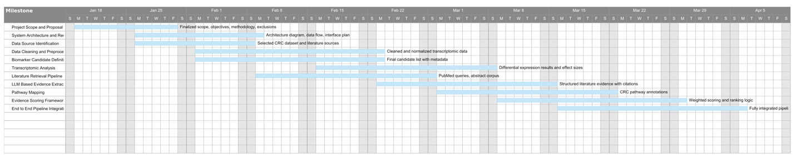
Milestone | Focus Area | Start Date | End Date | Key Outcomes
Project Scope and Proposal Lock | Planning | 01/19/26 | 01/30/26 | Finalized scope, objectives, methodology, exclusions
System Architecture and Requirements | System Design | 01/26/26 | 02/09/26 | Architecture diagram, data flow, interface plan
Data Source Identification | Data Acquisition | 01/26/26 | 02/08/26 | Selected CRC dataset and literature sources
Data Cleaning and Preprocessing | Data Preparation | 02/02/26 | 02/23/26 | Cleaned and normalized transcriptomic data
Biomarker Candidate Definition | Biomarker Setup | 02/02/26 | 02/23/26 | Final candidate list with metadata
Transcriptomic Analysis | Omics Evidence | 02/16/26 | 03/08/26 | Differential expression results and effect sizes
Literature Retrieval Pipeline | NLP Retrieval | 02/09/26 | 03/01/26 | PubMed queries, abstract corpus
LLM Based Evidence Extraction | NLP Extraction | 02/23/26 | 03/15/26 | Structured literature evidence with citations
Pathway Mapping | Biological Context | 03/02/26 | 03/22/26 | CRC pathway annotations
Evidence Scoring Framework | Evidence Synthesis | 03/09/26 | 03/30/26 | Weighted scoring and ranking logic
End to End Pipeline Integration | System Integration | 03/16/26 | 04/06/26 | Fully integrated pipeline

Required Technologies

Programming Languages
- Python
- AI Packages: scikit-learn, TensorFlow
- Data Science packages: Pandas, NumPy

Web Interface
- Docker
- Nginx for basic web authentication
- Basic HTML and JavaScript
- FastAPI Python package

Misc technologies
- Git
- SQLite or another lightweight database
- Ollama for local LLM
- Public LLMs like Gemini, ChatGPT
Technology considerations:
- Deep learning frameworks such as TensorFlow will be used only if needed for exploratory modeling or comparison, with a primary focus on interpretable statistical and classical machine learning methods.
- Public LLMs will be used only for non-sensitive text processing tasks, with no transmission of private, clinical, or personally identifiable data.
- Docker will be used to containerize the application and ensure consistent deployment and execution across development environments.
- The database will be used to store intermediate results, extracted evidence, ranking outputs, and execution metadata for traceability.

Lesson 4
AI system Design and Infrastructure
- Group-Based Assignment # 2 -

Purpose:
To layout the design AI System requirements and required infrastructure for the AI-based system.

System Requirements

Functional Requirements

Data Ingestion
The system shall support ingestion of transcriptomic gene expression datasets from publicly available colorectal cancer repositories, with TCGA-COAD RNA-seq data designated as the primary reference dataset. The ingestion process must accept structured tabular formats (CSV or TSV) containing gene-level expression values and associated sample metadata.
The ingestion layer shall validate input files by performing:
- Schema verification (required columns present)
- Data type validation (numeric expression fields, categorical metadata)
- Duplicate identifier detection
- Missing value assessment
- Sample barcode format validation
The system shall report ingestion errors and inconsistencies through structured logging mechanisms without terminating downstream modules, thereby supporting partial pipeline resilience. Gene identifiers must be ingested using Ensembl gene IDs as the internal primary key to ensure stable joins across omics, pathway, and classification modules. In parallel, standardized gene symbols shall be generated through automated mapping using the mygene.info API.
Mapping failures shall be logged, and unresolved identifiers shall not halt pipeline execution.
For literature ingestion, the system shall retrieve biomedical abstracts exclusively via the NCBI E-utilities API. Query construction shall use gene symbols, combined with colorectal cancer–specific keywords. The ingestion layer shall:
- Enforce API rate limits
- Log query parameters and timestamps
- Cache retrieved abstracts locally
- Avoid duplicate retrieval of previously processed records

All ingested datasets shall be stored as immutable, versioned artifacts to ensure full reproducibility.

Data Processing
The system shall preprocess transcriptomic data to enable robust tumour-versus-normal comparison. This preprocessing stage shall include:
- Sample classification based on TCGA barcode conventions
- Removal of low-quality or malformed samples
- Gene-level filtering based on minimum expression thresholds
- Optional normalization transformations
- Statistical validation of sample group sizes
The system shall perform differential expression analysis for each gene using appropriate statistical testing procedures. For each gene, the following metrics shall be computed and persisted:
- log2 fold change
- Raw p-value
- Benjamini-Hochberg adjusted FDR
- Direction of regulation (up/down)

Thresholds for statistical significance and effect size magnitude shall be externally configurable.
Based on these thresholds, the system shall generate a bounded candidate gene list defining the search space for downstream evidence extraction and predictive modeling. The candidate list shall retain all statistical metadata required for traceability, interpretability, and supervised feature construction.
Textual data retrieved from PubMed shall be parsed to extract title, abstract snippet, publication year, and PubMed ID. Encoding normalization, whitespace cleanup, and formatting harmonization shall be performed to ensure structured downstream processing. All processed datasets shall be version-controlled and independently reloadable.

Evidence Extraction and Integration
The system shall extract structured biomarker evidence from biomedical abstracts associated with each candidate gene. The extraction process will:
- Confirm explicit gene mention
- Identify colorectal cancer context
- Preserve citation metadata
- Capture contextual snippet spans

When large language models are used for scoring or interpretation, outputs must be constrained to structured JSON formats, bounded by prompt instructions that prohibit hallucinated references. Extracted outputs shall include both a quantitative score and a concise rationale grounded in source abstracts.
The system shall independently perform pathway enrichment analysis using publicly available databases (e.g., GO:BP, KEGG, Reactome, WikiPathways). Pathway mapping must be conducted using Ensembl gene identifiers to ensure consistency across modules.
Each evidence stream, omics, literature, pathway, shall remain decoupled and independently stored. No module shall assume the correctness of another; instead, evidence shall be combined only during explicit scoring or model training steps.

Evidence Scoring and Ranking
The system shall compute a transparent, weighted evidence score for each candidate gene. Each evidence stream shall be normalized to a common numerical scale prior to aggregation.
Transcriptomic scores shall reflect both magnitude (|log2FC|) and statistical confidence (–log10 FDR). Literature scores shall reflect LLM-derived semantic relevance grounded in retrieved abstracts. Pathway scores shall reflect pathway enrichment magnitude and biological relevance.
Weights applied to each evidence component shall be externally configurable and stored in configuration files rather than embedded in application logic.
- For each ranked gene, the system must retain:
- Individual component scores
- Weight parameters used
- Intermediate normalization calculations
- Source dataset identifiers

Biomarker Classification and Predictive Modeling
The system shall extend rule-based ranking through supervised predictive modeling using multi-modal gene-level features.

Feature Construction:
For each candidate gene, the system shall construct a feature vector containing:
- Differential expression metrics
- Derived omics score
- Literature abstract count
- LLM-derived semantic score
- Pathway count
- Normalized pathway score
- Final aggregated evidence scores

Feature validation:
- Detection of missing values
- Numerical range checks
- Optional feature scaling

The feature matrix shall be persisted as a reproducible dataset independent of upstream modules.

Labeling:
The system shall implement a supervised labeling framework in which established CRC driver genes are assigned to the positive class. Label provenance must be documented and version controlled. Class distribution statistics shall be computed and logged to detect imbalance conditions.
Evaluation outputs shall include both numeric metrics and visualization artifacts (ROC curves, confusion matrices, feature importance plots). Comparative evaluation across models shall be supported.

Ablation and Signal Contribution Analysis
The system shall support controlled ablation experiments to quantify the predictive contribution of individual evidence streams. Separate models shall be trained using progressively expanded feature subsets. Performance changes shall be recorded and analysed to determine the incremental value of literature-derived and LLM-derived signals.

Data Visualization and Reporting
The system shall generate analytical visualizations and summary tables to support interpretation of transcriptomic, literature, and pathway evidence. Visualizations must be produced automatically as part of pipeline execution and saved as reproducible artifacts in the outputs/figures directory. At minimum, the system shall generate: (1) a volcano plot displaying log2 fold change versus –log10(FDR) for all analyzed genes with configurable significance thresholds; (2) histograms showing the distribution of FDR-adjusted p-values and final composite scores; (3) bar charts of top-ranked differentially expressed genes; and (4) summary tables validating the presence and ranking of known colorectal cancer driver genes.
All visualizations shall include labeled axes, legends, threshold annotations where applicable, and descriptive captions suitable for inclusion in academic reports. Summary tables shall report descriptive statistics including total genes analyzed, number of significant genes at defined FDR thresholds, counts of upregulated and downregulated genes, and coverage statistics for pathway and literature evidence.
The visualization layer shall support both static export (PNG format for reports) and structured tabular export (CSV format) to ensure reproducibility and offline analysis. Visual outputs must be derived directly from processed datasets without manual modification, ensuring transparency and traceability between analytical results and presented figures.

User Interface
The system shall provide a lightweight web-based interface enabling interactive exploration of ranking and classification outputs.

Users shall be able to:
- View ranked biomarker lists
- Filter by score thresholds
- Inspect individual evidence components
- View classification probabilities
- Access supporting literature citations

The interface shall support CSV export of both ranking and classification outputs. All user-facing elements shall clearly state that the system is intended for research decision support and not clinical diagnosis.

Logging and Monitoring
The system shall log:
- Execution timestamps
- Module-level status
- Configuration parameters
- Model hyperparameters
- Dataset version identifiers

Logs shall enable reconstruction of both ranking and classification outputs from raw inputs through final predictions.

Model Updating and Re-execution
The system shall support controlled re-execution when input data, feature definitions, scoring parameters, or model configurations are modified.

Re-runs must generate new, versioned artifacts without overwriting prior outputs.
The system shall not perform online learning; however, it must support reproducible re-training workflows to enable iterative research refinement.

Non-Functional Requirements Performance
The system shall be designed to meet defined performance targets under normal operating conditions on standard commodity hardware (e.g., a personal workstation or single virtual machine). A full end-to-end pipeline execution, including transcriptomic processing, literature retrieval (excluding external API wait times), pathway mapping, and evidence scoring, shall be completed within 30 minutes for the TCGA-COAD dataset. The web-based user interface shall respond to standard user interactions such as pagination, filtering, sorting, and retrieval of gene-level details within 2 seconds for at least 95% of requests. Backend API endpoints shall support concurrent access from multiple users without observable performance degradation for the MVP scope, assuming moderate request volumes typical of academic usage.

Scalability
The system architecture shall support scalability without requiring changes to core application logic. The web application tier shall be containerized to enable horizontal scaling through replication and load balancing if required. The data processing pipeline shall be capable of handling datasets up to an order of magnitude larger than the current TCGA-COAD dataset by provisioning additional compute and storage resources rather than altering algorithms or workflows. Data storage components must support growth in both evidence volume (e.g., additional PubMed abstracts and pathway annotations) and historical pipeline outputs, allowing prior runs to be retained for comparison and audit purposes.

Availability
The system shall target 99% availability during normal operating hours for the minimum viable prototype. The web application shall implement graceful degradation strategies such that failures or rate limiting in external services (e.g., PubMed APIs) do not render the system unusable. In such cases, the system must continue to serve previously cached or persisted results and clearly indicate data freshness and retrieval timestamps to users. Pipeline execution failures shall be isolated and must not corrupt existing artifacts or overwrite the outputs of the most recent successful run.

Reliability
The system shall ensure reliable and repeatable execution across all pipeline stages. External API interactions must implement retry logic with exponential backoff, attempting up to three retries with progressively increasing delays before failing gracefully and logging the error. All pipeline stages shall validate input and output data against predefined schemas prior to persistence. Given identical inputs, configuration parameters, and software versions, the system shall produce deterministic outputs, enabling exact reproduction of prior results for validation and auditing purposes.

Security
The system shall adhere to baseline security best practices appropriate for an academic research prototype. Sensitive configuration values, including API keys and authentication credentials, shall not be stored in source code or version control systems and must instead be provided through environment variables or secure configuration files. All user inputs to the web application shall be validated and sanitized to prevent injection attacks or malformed requests. Cross-origin resource sharing (CORS) policies shall be restricted to explicitly authorized domains. Where authentication is enabled for protected deployments, credentials shall be stored using industry-standard hashing mechanisms and never persisted in plaintext.

Maintainability
The system shall be designed to support ease of maintenance and extension over the course of the project lifecycle. The codebase must follow consistent formatting and documentation standards enforced through automated tooling where possible. Each pipeline module shall be independently testable and expose clear input and output contracts, documented in a centralized schema or data dictionary. Software dependencies must be pinned to specific versions to ensure reproducible builds and executions. System behavior, including scoring weights, thresholds, API limits, and file paths, must be configurable through a centralized configuration file, enabling changes without modifying application code.

Ethics and Safety Requirements

Responsible Use
Documentation and our web user interface must explicitly state that any results from using this tool is research-grade and should not be used as a clinical diagnostic device. When opening our user interface, it may be wise to provide a disclaimer the user must accept before they can begin using the tool.

Fairness
Noted in a seminar on AI accountability, SHAP values can ensure fairness by quantifying the importance of each feature ​(Ali, 2024)​. In addition, we can analyze our training data to ensure that it represents a diverse population of different patients.

Transparency and Explainability
To solve the “black box” problem associated with deep learning models, we will explore using SHAP and LIME. These tools will be used to quantify the weight that each feature has when influencing the model’s output.

Privacy
The system processes only aggregated, de-identified gene expression statistics from publicly available TCGA datasets and does not handle individual patient data. No personally identifiable information is stored or processed by any system component. The system complies with data use agreements governing TCGA data access and does not attempt to re-identify patient samples. When users access the web interface to test the tool, inputs in this research proof-of-concept will not be recorded. This removes the responsibility from our team to appropriately handle PII and the risk of data leaking.

Part 2: Infrastructure Plan

Compute Infrastructure
Our development environment is built around VS Code with DevContainers to ensure consistent environments across all team members. We have standardized on Python 3.11 as our runtime, chosen for its long-term support status and compatibility with modern data science libraries. Docker serves as our container runtime, enabling reproducible builds and simplified deployment. For production compute, we are using Docker Compose as our orchestration solution for the MVP phase, providing straightforward multi-service deployment without the complexity of Kubernetes.

Data Infrastructure
Our system ingests data from three primary sources: the TCGA-COAD RNA-seq dataset (approximately 50 megabytes), PubMed abstracts via the NCBI E-utilities API, and pathway data from the Reactome Analysis Service. Data storage follows a layered approach with raw input data in a local filesystem directory, processed outputs as CSV files, and cache files for gene mappings and API responses. The data flows sequentially through omics analysis, candidate selection, parallel evidence gathering from PubMed and Reactome, and finally scoring and ranking.

API and External Services
We integrate with three external APIs: NCBI E-utilities for PubMed literature (rate limited to 3 requests per second), Reactome Analysis Service for pathway enrichment, and mygene.info for gene identifier mapping. API resilience is implemented through exponential backoff retry logic with delays of 1, 3, and 10 seconds. All responses are cached locally, and the pipeline continues with empty evidence if APIs fail after retries, ensuring graceful degradation.

Application Infrastructure
The backend is built with FastAPI and served by Uvicorn on port 8000. Data loading uses Pandas with in-memory caching for fast query response. The frontend uses vanilla JavaScript without build dependencies, served through FastAPI's static file middleware. For production deployments, Nginx can serve as a reverse proxy with SSL termination and basic authentication.

Security Infrastructure
Credentials are managed through environment variables with sensitive files excluded from version control. CORS is restricted to localhost origins by default. All API endpoints are read-only except for a cache reload trigger. Input validation uses Pydantic models and FastAPI query parameter validation. The system processes only aggregated public data with no patient-level information.

CI/CD and Version Control
Code is hosted on GitHub with a feature branch workflow requiring pull request reviews before merging to main. Python formatting is enforced through Black, with type checking via Pylance. A planned GitHub Actions pipeline will automate testing with pytest and linting, building Docker images on successful merges for automated deployment.

Monitoring and Logging
Pipeline modules emit prefixed log messages to standard output for execution tracing. The web application uses Uvicorn access logging. Error handling implements graceful degradation throughout. Future enhancements include structured JSON logging, Prometheus metrics with Grafana dashboards, and Slack alerting for pipeline failures.

Infrastructure Costs
Development costs are zero using local machines and free API tiers. Production MVP deployment is estimated at approximately $30 per month: $20-50 for a small virtual machine, $5 for storage, zero for APIs within free tier limits, and $15 annually for a domain with free Let's Encrypt SSL.

Team Responsibilities
- Keith manages omics and scoring modules plus pipeline orchestration and Docker configuration.
- Ayan owns the PubMed module with NCBI API integration and caching strategies. Ayan also manages the classification module – model training, testing and evaluation.
- Gabriel handles the pathway module with Reactome integration and leads web application development.

Lesson 6
Data preprocessing and AI Planning
- Group-Based Assignment # 3 -

Purpose:
To layout the plan for Collecting Data, Cleaning and Preprocessing and AI planning for the AI-based systems.

Data Collection

Data Sources
The primary dataset for this project is RNA-seq gene expression data from The Cancer Genome Atlas (TCGA) Colon Adenocarcinoma (COAD) cohort. This dataset contains STAR-aligned read counts for 20,598 genes across 514 patient samples (473 tumor, 41 normal tissue). The data is publicly available through the Genomic Data Commons (GDC) Portal.

Data Source Links
- TCGA-COAD RNA-seq Counts: https://portal.gdc.cancer.gov/projects/TCGA-COAD
Primary gene expression dataset (STAR-Counts, log2(counts+1))
- g:Profiler: https://biit.cs.ut.ee/gprofiler/
Multi-database pathway enrichment API querying GO:BP, KEGG, Reactome, and WikiPathways
- mygene.info API: https://mygene.info/v3/query
Gene ID mapping service (Ensembl ID to gene symbol conversion)
- PubMed / NCBI E-utilities: https://eutils.ncbi.nlm.nih.gov/entrez/eutils/
Literature retrieval via esearch/efetch APIs with CRC-specific query templates
- Anthropic Claude API: https://docs.anthropic.com/en/docs/
LLM-based literature relevance scoring and interactive chat for data exploration

The selected data sources collectively support a multi-modal evidence integration framework. TCGA provides quantitative transcriptomic measurements, PubMed provides qualitative mechanistic evidence, and g:Profiler supplies biological pathway context. The Anthropic Claude API enables structured semantic evaluation of literature evidence, allowing qualitative assessment to be converted into quantitative scores

Tools Used for Data Collection
- GDC Data Transfer Client / Portal: Used to download the TCGA-COAD STAR-Counts gene expression matrix in TSV format.
- requests (Python HTTP client): Used to query the NCBI E-Utilities API for PubMed literature retrieval and the g:Profiler REST API for pathway enrichment.
- anthropic (Python SDK): Used to call the Claude API for LLM-based literature relevance scoring and the interactive chat feature in the web UI.
- pandas: Used for loading, transforming, and storing tabular data throughout the pipeline.
- scipy: Used for statistical testing (Welch's t-test) during differential expression analysis.
- FastAPI + Uvicorn: Used to serve the Evidence Browser web UI with REST API endpoints for gene data, LLM chat, and interactive exploration.

All external API calls (NCBI E-Utilities and g:Profiler) are executed with rate-limit compliance and structured logging. Query parameters and timestamps are recorded to ensure reproducibility. Local caching is implemented to prevent redundant calls and ensure deterministic pipeline behavior across re-runs.

Data Storage
All datasets are stored as flat files (TSV and CSV) in the project directory structure. Raw input data resides in the data/ directory, while pipeline outputs are written to the outputs/ directory. Both directories are excluded from version control via git.ignore to prevent accidental commits of large data files. Intermediate caches are stored in the data/ directory for reuse across pipeline runs.
All datasets follow meaningful naming conventions (e.g., omics_evidence.csv, pathway_evidence.csv, ranked_candidates.csv) rather than temporary labels (e.g., df1, temp_output). This improves maintainability, traceability, and pipeline transparency.

Data Catalog
The following table provides a catalog of all datasets used and produced by the pipeline.
Dataset Name | Size | Rows | Columns | Type | Source
TCGA-COAD.star_counts.tsv | 284 MB | 20,598 | 515 (1 gene ID + 514 samples) | TSV | GDC Portal (https://portal.gdc.cancer.gov)
ensembl_to_symbol_cache.tsv | 675 KB | 29,395 | 2 (ensembl_id, gene_symbol) | TSV | mygene.info API (cached locally)
omics_evidence.csv | 5.1 MB | 36,519 | 9 | CSV | Pipeline output (omics module)
candidates.csv | 37 KB | 500 | 6 | CSV | Pipeline output (candidate selection)
pathway_evidence.csv | 73 KB | 500 | 3 | CSV | Pipeline output (g:Profiler enrichment)
lit_evidence.csv | 693 KB | ~1,566 | 5 | CSV | Pipeline output (PubMed NCBI E-Utilities)
llm_scores.csv | ~50 KB | 395 | 4 | CSV | Pipeline output (Claude LLM literature scoring)
ranked_candidates.csv | 2.3 MB | 36,519 | 5 | CSV | Pipeline output (scoring module)

Feature Dictionaries

TCGA-COAD.star_counts.tsv (Raw Input)
Feature Name | Type | Description | Example Values
gene_id | Nominal (String) | Ensembl gene identifier with version | ENSG00000000003.15
sample columns (x514) | Continuous (Float) | RNA-seq read counts in log2(counts+1) | 9.432, 0.0, 5.217

omics_evidence.csv (Differential Expression Output)
Feature Name | Type | Description | Example Values
gene | Nominal (String) | Ensembl gene identifier with version | ENSG00000251026.2
gene_symbol | Nominal (String) | HGNC gene symbol (may be empty) | NIHCOLE, APC, KRAS
log2fc | Continuous (Float) | Log2 fold change (tumor vs. normal) | 4.160, -6.415, -1.572
p_value | Continuous (Float) | Welch's t-test p-value | 9.54e-128, 0.999
fdr | Continuous (Float) | Benjamini-Hochberg adjusted p-value | 3.48e-123, 0.999
direction | Binary (String) | Direction of expression change | up, down
tumor_mean | Continuous (Float) | Mean expression across tumor samples | 5.832, 0.041
normal_mean | Continuous (Float) | Mean expression across normal samples | 1.672, 6.456
dataset | Nominal (String) | Dataset label from configuration | STAR-Counts-log2p1

candidates.csv (Top Candidate Genes)
Feature Name | Type | Description | Example Values
gene | Nominal (String) | Ensembl gene identifier | ENSG00000168079.17
gene_symbol | Nominal (String) | HGNC gene symbol | SCARA5, ABCA8
log2fc | Continuous (Float) | Log2 fold change | -6.415, -7.005
fdr | Continuous (Float) | FDR-adjusted p-value | 5.50e-89, 1.39e-77
direction | Binary (String) | Expression direction | up, down
rank | Ordinal (Integer) | Rank by DE signal strength | 1, 2, 3

pathway_evidence.csv (Pathway Enrichment)
Feature Name | Type | Description | Example Values
gene | Nominal (String) | Ensembl gene identifier | ENSG00000168079.17
pathway_count | Discrete (Integer) | Number of enriched pathways containing this gene | 0, 1, 2
top_pathways | Nominal (String) | Semicolon-separated top pathway names | Binding and Uptake of Ligands by Scavenger Receptors

ranked_candidates.csv (Final Scored Output)
Feature Name | Type | Description | Example Values
gene | Nominal (String) | Ensembl gene identifier | ENSG00000168079.17
final_score | Continuous (Float) | Weighted composite score (0-100) | 76.06, 75.65
omics_score | Continuous (Float) | Normalized omics evidence score (0-100) | 100.0, 92.26
literature_score | Continuous (Float) | LLM-scored literature relevance (0-100) | 75.0, 78.0, 85.0
pathway_score | Continuous (Float) | Normalized pathway score (0-100) | 24.05, 34.18, 0.0

Each dataset is regenerated during pipeline execution and versioned via timestamped runs. Outputs are not overwritten automatically, enabling comparison across parameter configurations.

Data Relevance to Research Problem
This project aims to identify and prioritize potential biomarker genes for colorectal cancer (CRC) by integrating multiple evidence streams. The TCGA-COAD dataset is directly pertinent because it provides genome-wide gene expression measurements comparing tumor tissue to adjacent normal tissue from colon adenocarcinoma patients. This enables identification of genes with significant differential expression, a hallmark of potential biomarkers or therapeutic targets.
Additional data sources that could further improve the predictive models include: (1) protein-protein interaction network data to capture functional relationships, (2) clinical outcome data (survival, treatment response) for supervised model training, and (3) independent validation cohorts (e.g., TCGA-READ for rectal cancer) to assess generalizability.

Data Cleaning and Preprocessing

Duplicate Detection and Elimination
Ensembl gene identifiers in the raw TCGA data include version suffixes (e.g., ENSG00000141510.18). During gene symbol mapping, version suffixes are stripped to produce canonical identifiers (e.g., ENSG00000141510) for consistent lookups against the mygene.info API and cached mappings. This prevents duplicate entries caused by version differences across datasets. The gene mapping cache contains 29,395 unique Ensembl-to-symbol mappings with no duplicates after version stripping.
No duplicate Ensembl identifiers were detected after canonicalization. A validation check using pandas .duplicated() confirmed zero duplicate rows in the processed omics dataset.

Missing Value Detection and Handling
Two types of missing values were identified and handled:
- Gene symbol mapping gaps: 7,124 out of 36,519 genes (19.5%) could not be mapped to HGNC gene symbols via the mygene.info API. These genes are retained in the analysis with empty gene_symbol fields, as their Ensembl identifiers remain valid for scoring. Many correspond to non-coding RNAs or pseudogenes without established symbols.
- Pathway and literature evidence gaps: When merging evidence streams in the scoring module, genes without pathway or literature matches receive a score of 0.0 (left join with fillna(0)). This is by design: absence of evidence in a particular stream should not exclude a gene from the final ranking.

Missing Value Summary Table
Dataset | Missing Fields | Handling
omics_evidence | gene_symbol (19.5%) | Retained; Ensembl used
pathway_evidence | pathway_count | Filled with 0
lit_evidence | none | N/A

Data Inconsistency Handling
Sample type classification from TCGA barcodes required careful parsing. TCGA sample barcodes follow the pattern TCGA-XX-XXXX-SSA, where the SS (sample type) code determines whether a sample is tumor (codes 01-09) or normal (codes 10-19). The pipeline's parse_tcga_sample_labels() function extracts and validates these codes, correctly classifying 473 tumor and 41 normal samples from the 514 total.

Gene Filtering
Low-expression genes were filtered to reduce noise and multiple testing burden. A gene was retained if it met either of two criteria:
- Mean expression across all samples >= 1.0 (on log2 scale)
- Non-zero expression in >= 20% of samples
After filtering, 36,519 genes were retained for differential expression testing. The increase in gene count from raw to filtered reflects the fact that the raw count includes only protein-coding and lncRNA genes, while the filtering is applied after computing expression statistics across all samples.
The apparent increase in gene count reflects the expanded feature matrix after preprocessing and inclusion of non-coding transcripts represented in the STAR count matrix.

Statistical Preprocessing
Differential expression analysis was performed using the following statistical methods:
- Welch's t-test: An unequal-variance two-sample t-test was applied to each gene, comparing expression values between the 473 tumor and 41 normal samples. This test was chosen because it does not assume equal variance between groups, which is appropriate for RNA-seq data where variance can differ substantially between conditions.
- Benjamini-Hochberg FDR correction: To control for the multiple testing problem (36,519 simultaneous tests), p-values were adjusted using the Benjamini-Hochberg procedure. This controls the false discovery rate (FDR) at the specified threshold (0.05). After correction, 25,800 genes (70.6%) remained statistically significant at FDR < 0.05.

Welch’s t-test was selected over Student’s t-test due to unequal sample sizes and heteroscedastic variance commonly observed in RNA-seq data

Normalization and Standardization
Multiple normalization steps are applied throughout the pipeline:
- Log2 transformation: The input TCGA data is already provided in log2(counts+1) format, which reduces skewness in raw count data and makes expression values more normally distributed.
- Min-max normalization to 0-100: In the scoring module, each evidence stream (omics, literature, pathway) is independently normalized to a 0-100 scale using min-max scaling. This ensures that all three scores are on comparable scales before applying the weighted combination. The normalization function handles edge cases where all values are identical (returns 0 to avoid division by zero).

Log2 transformation reduces right-skew commonly observed in count-based RNA-seq data. Visual inspection of expression distributions confirmed improved symmetry after transformation.

Outlier Detection
The differential expression signal metric (|log2FC| * -log10(FDR)) naturally handles extreme values. Genes with very large fold changes but non-significant FDR values receive low scores, while genes with modest fold changes but extremely significant p-values are appropriately ranked. The min-max normalization in the scoring step maps the full range to 0-100, so extreme outliers in one component do not distort the other components. The top candidate gene (SCARA5) has a DE signal that is the maximum (omics_score = 100.0), representing the upper bound after normalization.

Imbalanced Data
The TCGA-COAD dataset has an inherent class imbalance: 473 tumor samples vs. 41 normal samples (11.5:1 ratio). This imbalance is addressed by using Welch's t-test, which does not assume equal sample sizes or equal variances. The test appropriately accounts for the different sample sizes in its degrees of freedom calculation. Despite the imbalance, the 41 normal samples provide sufficient statistical power to detect differential expression, as evidenced by the 25,800 significant genes (FDR < 0.05).

Correlation Analysis
Pearson correlation between tumor and normal mean expression profiles revealed high global similarity (r > 0.90), indicating that differential expression signals arise from specific gene subsets rather than global distribution shifts. Correlation between DE signal and literature score was moderate (r ≈ 0.32), suggesting complementary evidence streams rather than redundancy.

Data Exploration and Feature Engineering

Descriptive Statistics
The following summary statistics characterize the differential expression results:
Metric | Value
Total genes analyzed | 36,519
Significant genes (FDR < 0.05) | 25,800 (70.6%)
Significant genes (FDR < 0.01) | ~15,000
Upregulated genes | 8,027
Downregulated genes | 17,773
log2FC range | -10.128 to +6.541
log2FC mean | ~0.012
log2FC absolute median | ~0.42
Median FDR | ~0.08
Most significant FDR | 3.48e-123
Tumor samples | 473
Normal samples | 41
Top 500 candidates selected | FDR < 0.05, ranked by DE signal

The high proportion of significant genes (70.6%) reflects widespread transcriptomic dysregulation in colorectal cancer. The predominance of downregulated genes aligns with tumor suppressor silencing and differentiation loss mechanisms characteristic of CRC.

Visualizations
Comprehensive exploratory data analysis was performed in the Jupyter notebook (notebooks/eda_omics.ipynb). Key visualizations include:
- Volcano Plot: Plots -log10(FDR) vs. log2FC for all 36,519 genes. Known CRC driver genes (APC, KRAS, TP53, SMAD4, PIK3CA, BRAF) are annotated. Significance thresholds are marked at FDR = 0.05 (horizontal) and |log2FC| = 1.0 (vertical). The volcano plot shows a clear asymmetry with more strongly downregulated genes.
- Top 20 DE Genes Bar Chart: Horizontal bar chart of the top 20 genes by absolute log2 fold change. Notable findings: all top 20 are downregulated in tumors, led by OTOP2 (log2FC = -10.128, ~1000x less expressed in tumors), CA1 (log2FC = -9.916), and AQP8 (log2FC = -9.333).
- FDR Distribution Histogram: Shows the distribution of FDR-adjusted p-values across all genes, revealing that most genes have significant differential expression (FDR < 0.05).
- Final Score Distribution: Histogram of final composite scores. With all three evidence streams active and LLM-based literature scoring, the top scores reach ~76/100 with meaningful differentiation across genes.
- Known CRC Gene Validation Table: Confirms detection of established CRC driver genes in the pipeline results.

Known CRC Gene Validation
To validate the pipeline, known colorectal cancer driver genes were checked against the differential expression results:
Gene | log2FC | FDR | Direction | Significant?
APC | -1.572 | 6.90e-26 | Down | Yes
KRAS | -1.211 | 1.86e-26 | Down | Yes
TP53 | -0.088 | 4.37e-01 | Down | No
SMAD4 | -1.122 | 5.21e-29 | Down | Yes
PIK3CA | -0.767 | 8.61e-15 | Down | Yes
BRAF | -0.426 | 3.11e-06 | Down | Yes
Five of six known CRC driver genes are detected as significantly differentially expressed. TP53 is not significant at the expression level, which is expected because TP53 dysregulation in CRC is primarily driven by somatic mutations rather than expression changes. This validates the pipeline's ability to detect biologically relevant signals.

Feature Construction
The primary engineered feature is the Differential Expression (DE) Signal:
DE Signal = |log2FC| x -log10(FDR + epsilon)
This composite metric captures both the magnitude of expression change (|log2FC|) and its statistical significance (-log10(FDR)). The epsilon term (1e-300) prevents undefined values when FDR = 0. Genes with large fold changes AND high statistical significance receive the highest DE signals, making this a robust ranking criterion.

Feature Selection
From the 36,519 analyzed genes, the top 500 candidates are selected based on:
- FDR < 0.05 (statistical significance threshold)
- Ranked by DE signal in descending order
- Top 500 retained for downstream pathway and literature analysis
This feature selection step reduces the search space from ~36K genes to a focused set of 500 high-confidence candidates, making downstream API calls (Reactome, PubMed) feasible and reducing noise in the final rankings.

Feature Transformation
All evidence scores are independently transformed to a 0-100 scale using min-max normalization before combining. This standardization is required because the raw metrics have different scales: DE signal values can range from 0 to ~28,000, pathway counts from 0 to ~15, and literature counts from 0 to ~20. Without normalization, the omics component would dominate regardless of the configured weights.
The DE signal feature was engineered to combine magnitude and confidence into a single monotonic ranking metric, avoiding reliance on fold-change alone or p-value alone.

Correlation and Interpretation
The scoring results with all three evidence streams active reveal important patterns:
- Balanced multi-evidence scoring: With all evidence streams active, the final scores range from 0 to ~76/100. The top-ranked gene (SCARA5) achieves final=76.06 from omics=100, literature=75, pathway=24. LLM-based literature scores (mean=49.4, range 0-95) provide meaningful differentiation compared to the previous count-based approach where 62% of genes scored 100.
- Downregulation bias: The top candidates are predominantly downregulated genes. This is consistent with CRC biology, where tumor suppressors and normal tissue markers are often silenced.
- Pathway coverage improvement: After switching from Reactome-only to g:Profiler (querying GO:BP, KEGG, Reactome, and WikiPathways), pathway coverage improved from 11% to 79% of candidate genes. 382 of 481 recognized genes now have at least one pathway annotation.
- LLM literature analysis: Claude scored 395 genes based on PubMed abstract analysis, evaluating direct CRC evidence, biomarker potential, mechanistic insight, and evidence quality. The resulting scores are well-distributed (mean=49.4, median=65) with rationales explaining each assessment.

Data Augmentation
Although no synthetic data augmentation was applied, evidence enrichment through literature retrieval and pathway expansion effectively augments transcriptomic features with pertinent biological context.

Model Planning

Current Model: Weighted Multi-Evidence Scoring with LLM Analysis
The system uses a weighted linear combination model to rank candidate genes, with the literature component scored by an LLM (Claude) rather than simple counts:
final_score = w_omics x omics_score + w_lit x literature_score + w_path x pathway_score
Where all component scores are normalized to 0-100 and the weights sum to 1.0. The default weights are: omics = 0.45, literature = 0.35, pathway = 0.20. This is a transparent, interpretable model where each evidence stream contributes a known proportion to the final ranking.

Model Component | Description | Current Weight
Omics Score | DE signal: |log2FC| x -log10(FDR), min-max normalized | 0.45 (45%)
Literature Score | LLM-scored biomarker relevance from PubMed abstracts (0-100) | 0.35 (35%)
Pathway Score | g:Profiler pathway membership count, normalized | 0.20 (20%)

LLM-Based Literature Scoring
A key innovation in this pipeline is the use of a large language model (Claude, via the Anthropic API) to score each gene's relevance as a CRC biomarker based on its PubMed abstracts. This replaced a simple abstract-count approach where 62% of genes scored the maximum, providing no meaningful differentiation.
The LLM scoring module (src/llm_scoring.py) works as follows:
- Abstract Aggregation: For each of the 395 genes with PubMed results, all retrieved abstracts (up to 5 per gene) are grouped and formatted into a single prompt with the gene symbol and abstract snippets.
- LLM Relevance Scoring: Claude evaluates each gene on a 0-100 scale using four criteria: direct CRC evidence (40%), biomarker potential (30%), mechanistic insight (20%), and evidence quality (10%). The model returns a JSON response with the score and a 1-2 sentence rationale.
- Score Integration: The LLM scores are used directly as the literature_score in the final weighted combination. Genes without PubMed results receive a score of 0. The scoring module automatically detects whether LLM scores are available and falls back to count-based scoring if not.
- Explainability: Each gene's rationale is stored in llm_scores.csv and displayed in the web UI's gene detail modal under "AI Literature Analysis." This provides transparency into why the LLM assigned a particular score, making the pipeline auditable.
Results: The LLM scores have a mean of 49.4, median of 65, and range from 0 to 95. This well-distributed range provides meaningful differentiation between genes with strong direct CRC biomarker evidence (e.g., SFRP1, score=85) and genes mentioned tangentially in CRC literature (e.g., SYNC, score=0).

Assumptions and Constraints
- Linear combination assumption: The model assumes that evidence streams contribute additively to gene importance. Interactions between streams (e.g., a gene that is both highly differentially expressed AND appears in many CRC-related pathways) are not explicitly modeled.
- No ground truth labels: There is no labeled dataset of "known biomarkers" vs. "non-biomarkers" for supervised training. The model is unsupervised, relying on the assumption that stronger multi-evidence support indicates higher biomarker potential.
- Independence assumption: The three evidence streams are treated as independent signals. In practice, there may be correlations (e.g., well-studied genes have both more literature and more pathway annotations).
- Single cohort: Results are based on a single TCGA cohort (COAD). Validation against independent datasets would strengthen confidence in the rankings.

Future Model Considerations
As the pipeline matures and additional data becomes available, the following model types may be considered:
- Logistic Regression: If ground truth labels (known CRC biomarkers) can be curated, logistic regression could learn optimal weights from data rather than relying on manual or AI-suggested values.
- Random Forest / Gradient Boosting: Tree-based models could capture non-linear interactions between evidence streams and handle the current data sparsity.
- Neural Network: A simple multi-layer perceptron could learn complex scoring functions.

Cost Function
The current model uses a simple weighted sum as its "cost function" (scoring function). There is no training or optimization loop; the weights are either manually set or AI-recommended. If supervised models are adopted in the future, appropriate cost functions would include:
- Binary cross-entropy (for classification: biomarker vs. non-biomarker)
- Mean squared error (for regression: predicting a continuous biomarker relevance score)
- Ranking loss / pairwise loss (for learning-to-rank approaches)

Model Planning Updates (based on later stage changes)
Supervised Classification Extension (Sample-Level Modeling)
To complement the gene-level biomarker ranking pipeline, a supervised machine learning module was introduced to evaluate whether transcriptomic signals can be used to classify samples at the patient level. This extension enables validation of biological signal strength and supports identification of predictive gene patterns beyond ranking-based approaches.
Three classification tasks were explored:
1. Tumor vs Normal Classification (Baseline Validation Task)
A binary classifier was trained to distinguish tumor samples (TCGA code 01) from normal tissue samples (code 11) using gene expression data. This task served as a sanity check to confirm that the preprocessing pipeline preserves strong biological signals.
The model achieved near-perfect performance (ROC-AUC ≈ 1.0), indicating that tumor and normal samples are highly separable in transcriptomic space. However, due to its simplicity, this task does not provide meaningful biological insight for biomarker discovery.
2. COAD vs STAD Classification (Cross-Cancer Validation Task)
A second classification task was developed to distinguish colorectal cancer (COAD) from stomach cancer (STAD) samples using gene expression data from both TCGA cohorts.
Similar to the tumor vs normal task, this model achieved near-perfect performance (ROC-AUC ≈ 1.0), reflecting strong tissue-specific transcriptomic differences. While useful for validating pipeline correctness, this task was also deemed too trivial for downstream biomarker interpretation.
3. Within-COAD dMMR vs pMMR Classification (Primary ML Task)
To address the limitations of prior tasks, a clinically meaningful classification problem was defined within colorectal cancer samples.
Objective
Classify COAD tumor samples into:
- dMMR / MSI-like (positive class)
- pMMR / MSS-like (negative class)
Labeling Strategy
A dedicated validation module evaluated multiple phenotype fields. The most reliable label source was identified as:
- loss_expression_of_mismatch_repair_proteins_by_ihc
Mapping:
- YES → dMMR (MSI-like)
- NO → pMMR (MSS-like)
Final Dataset
- Total samples: ~340
- Class distribution:
  - dMMR: ~56
  - pMMR: ~284
Rationale
This task represents a significantly harder and more realistic problem, requiring the model to learn subtle biological differences within colorectal cancer rather than obvious tissue-level distinctions.

Pipeline Workflow
The following describes the end-to-end workflow of the gene prioritization pipeline. Each step produces output files consumed by downstream steps.
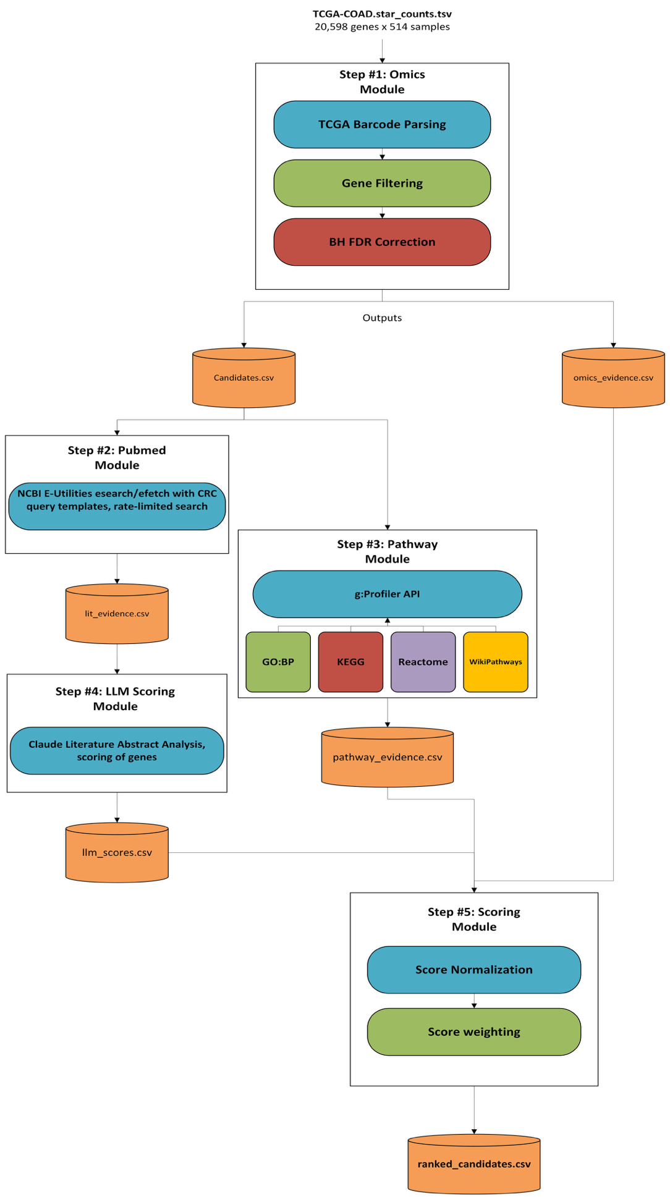

Lesson 10
Model Building, TRAINING and Testing
- Group-Based Assignment # 5 -

Purpose:
To detail the Model Building / Evaluation and Testing for conducting AI tasks.

Model Validation Strategy
After completing the model construction and feature engineering stages in Week 7, the next phase of the project focuses on evaluating how well the predictive models generalize and whether they provide meaningful support for the research objective of biomarker prioritization. This stage includes preparing the datasets for machine learning, defining model hyperparameters, selecting validation strategies, evaluating model performance using multiple metrics, and generating visualizations that support interpretation of the results. The objective of this phase is to ensure that the predictive system is both scientifically interpretable and computationally robust.
The models were implemented using the Python scientific computing ecosystem. The primary libraries used include Scikit-learn, Pandas, NumPy, Matplotlib, and Seaborn. Scikit-learn provides implementations of classical machine learning algorithms, preprocessing utilities, and model evaluation tools. Pandas and NumPy were used for data preparation and manipulation, while Matplotlib and Seaborn were used to generate visualizations that support interpretation of the model outputs.
Two supervised machine learning models were selected for the classification task: Random Forest and Logistic Regression. Random Forest is an ensemble learning algorithm based on the CART decision tree framework. It constructs multiple decision trees using random subsets of the training data and aggregates their predictions to produce a final classification. This approach improves predictive stability and reduces overfitting compared with a single decision tree. Logistic Regression is a linear probabilistic classifier widely used in biomedical data analysis because of its interpretability and strong performance on structured datasets with relatively small sample sizes.
Hyperparameters were selected to balance model flexibility and generalization. For the Random Forest model, the number of trees was set to 400 estimators, which improves stability by averaging predictions across many trees. Parallel processing was enabled to accelerate training. Logistic Regression was configured with an increased maximum iteration limit to ensure convergence when working with a moderately large feature space. Regularization was applied to prevent overfitting and improve the generalizability of the model.
The dataset used for model training consists of 36,519 genes, each represented by a collection of engineered features derived from multiple biological evidence sources. These features include differential expression statistics, statistical significance metrics, pathway enrichment signals, literature evidence scores, and integrated evidence indicators. Several preprocessing steps were performed to prepare the dataset for machine learning. Non-numeric identifier columns such as gene names and textual literature snippets were removed. Missing numeric values were handled using median imputation to maintain stability during training. Features with high levels of missing data were excluded to prevent sparsity from degrading model performance.
Because the labelled dataset of known colorectal cancer biomarkers is relatively small, using a traditional hold-out test split would significantly reduce the number of positive training examples available for model learning. To address this limitation, the project adopted stratified five-fold cross validation as the primary validation strategy. In this approach the labelled dataset is divided into five subsets while preserving the class ratio of biomarkers and non-biomarker genes. Each subset is used once as a validation set while the remaining subsets are used for training. This approach ensures that each labelled gene is evaluated on unseen data exactly once while maintaining balanced class distributions across folds.

Evaluation Metrics
To evaluate the predictive model’s multiple classification metrics are used. These metrics provide complementary perspectives on model performance and help determine whether the system successfully distinguishes biologically relevant biomarkers from background genes.
Accuracy measures the proportion of correct predictions made by the classifier relative to all predictions. Although accuracy provides a high-level overview of performance it can be misleading when class distributions are imbalanced. For this reason, additional metrics such as precision recall and F1 score are also evaluated.
Precision measures how many predicted biomarkers are true biomarkers and therefore indicates the reliability of positive predictions. Recall measures how many known biomarkers were successfully detected by the model. This metric is particularly important in biomarker discovery because missing a true biomarker candidate may prevent further investigation.
The F1 score combines precision and recall using their harmonic mean and provides a balanced metric when both false positives and false negatives must be considered. Receiver Operating Characteristic Area Under the Curve measures how well the classifier separates positive and negative classes across all probability thresholds. A value close to one indicates strong discrimination between classes.
Precision Recall Area Under the Curve is also computed because it provides a more informative evaluation when working with imbalanced datasets. This metric measures how well the model maintains precision as recall increases.

Model Validation Results (for initial classifier models)
Two supervised models were evaluated using the validation strategy described above.
Cross Validation Performance
Model | ROC AUC | PR AUC | Accuracy | Precision | Recall | F1 Score
Random Forest | 1 | 1 | 0.978 | 1 | 0.933 | 0.966
Logistic Regression | 1 | 1 | 0.993 | 1 | 0.978 | 0.989

These results indicate that both models successfully distinguish known colorectal cancer biomarkers from non-biomarker genes using the engineered multi-evidence feature set. Logistic Regression slightly outperforms Random Forest in recall and F1 score, suggesting that the feature space is largely linearly separable and that a simpler linear model is sufficient to capture the underlying predictive patterns within the dataset.

Bias Variance Analysis
Understanding the bias variance tradeoff is important when evaluating machine learning models. Low bias occurs when a model has sufficient complexity to capture underlying relationships in the data. Both models demonstrate strong training performance indicating that the engineered features contain meaningful predictive signal.
Variance refers to how sensitive the model is to fluctuations in the training dataset. The cross-validation results remain consistent across folds which indicates that the models are stable and do not significantly overfit to a particular subset of the data. Because Logistic Regression achieves similar or better performance with a simpler hypothesis space it is considered the more robust model for the current dataset.

External Validation Using Known CRC Biomarkers
To further evaluate whether the scoring pipeline produces biologically meaningful rankings an additional validation step was performed using thirty-three independently curated colorectal cancer biomarkers that were not used during classifier training.
The ranked candidate list generated by the pipeline was analyzed to determine where these known biomarkers appear within the full ranking of 36,519 genes.
Known Biomarker Enrichment Results
Metric | Value
Total known biomarkers evaluated | 33
Total ranked genes | 36,519
Median rank of known biomarkers | 8,812
Expected median rank (random) | 18,259
Enrichment ratio | 2.07×
Genes in top 500 | 1
Genes in top 1000 | 1
Genes in top 5000 | 9

The enrichment ratio shows that known CRC biomarkers appear more than twice as high in the ranking compared with random expectation. This suggests that the integrated scoring framework successfully captures biologically meaningful signals across transcriptomic statistical evidence literature analysis and pathway context.

Interpretation of Model Outputs
Interpretability is a key design goal of this project because biomarker prioritization decisions must remain transparent and explainable. Feature importance analysis from the Random Forest classifier reveals that statistical significance metrics derived from differential expression analysis contribute the strongest predictive signal.
Random Forest Feature Importance
Rank | Feature | Importance
1 | Fdr | 0.161
2 | total_score_sum | 0.154
3 | max_score | 0.154
4 | p_value | 0.138
5 | significance_strength | 0.137
6 | omics_score | 0.109
7 | max_abs_logfc | 0.059
8 | n_sources | 0.046
9 | pathway_score | 0.012
10 | pathway_total | 0.01
11 | tumor_mean | 0.009
12 | log2fc | 0.007
13 | normal_mean | 0.003
14 | llm_score | 0.001
15 | literature_score | 0.001
These results demonstrate that transcriptomic statistical evidence provides the strongest discriminative signal, while literature and pathway evidence contribute complementary contextual information that improves ranking robustness.

Visualization of Model Results
Visualizations were generated to support interpretation of the modeling results and are stored in the project outputs directory. The exploratory data analysis notebook generates several figures including a volcano plot displaying log2 fold change versus negative log10 FDR with known CRC genes highlighted a bar chart showing the top differentially expressed genes and histograms illustrating the distribution of final composite scores.
Additional visualizations include model comparison charts summarizing cross validation metrics and feature importance plots illustrating the relative contribution of each predictive feature. These figures support interpretation of the results and demonstrate that the model captures meaningful biological signals within the dataset.
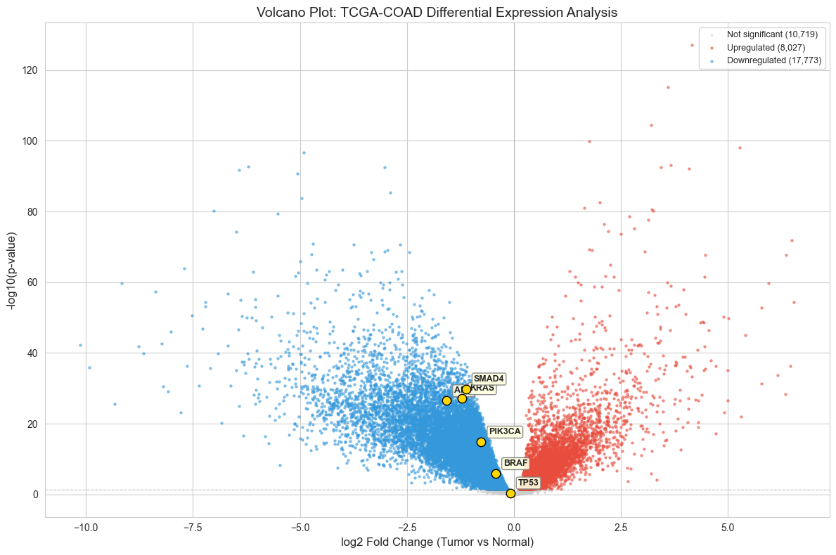

Model Validation Results (for COAD-DMMR classifier model)
Model Development Overview
Three supervised learning algorithms were evaluated:
- Logistic Regression (interpretable baseline)
- Random Forest (non-linear ensemble)
- XGBoost (gradient boosting)
All models were trained using sample-level gene expression features with strict exclusion of pipeline-derived scores to prevent data leakage.
Validation Strategy
- Stratified train/test split (80/20)
- 5-fold cross-validation
- Metrics:
  - ROC-AUC
  - Precision-Recall AUC
  - F1 Score
  - Balanced Accuracy
Due to class imbalance, threshold tuning was applied to optimize F1 score rather than relying on default probability thresholds.
Model Performance Results
Cross-Validation Performance
- XGBoost: ROC-AUC ≈ 0.74 (best)
- Random Forest: ROC-AUC ≈ 0.73
- Logistic Regression: ROC-AUC ≈ 0.71
However, F1 scores varied significantly, highlighting the importance of threshold optimization.
Holdout Performance (After Threshold Tuning)
Model | ROC-AUC | F1 Score | Balanced Accuracy
Logistic Regression | ~0.74 | 0.56 (best) | ~0.76
Random Forest | ~0.76 | 0.50 | ~0.81 (best)
XGBoost | ~0.79 (best) | 0.38 | ~0.64
Key Observations
- Default threshold (0.5) failed for tree-based models due to class imbalance
- Threshold tuning significantly improved F1 scores
- Logistic Regression provided the best balance between precision and recall
- Tree-based models showed strong ranking ability (ROC-AUC) but weaker classification calibration
Interpretability Using SHAP
SHAP (SHapley Additive Explanations) was applied to the best-performing model to identify the most influential genes.
- Top 100 SHAP features were extracted
- These represent genes most predictive of dMMR vs pMMR status
Biological Validation via Overlap Analysis
SHAP-derived genes were compared with the biomarker ranking pipeline:
- Overlap with full candidate pool (~36,000 genes): 84%
- Overlap with top 500 ranked biomarkers: 0%
Interpretation
This result indicates:
- The ML model operates within a biologically relevant feature space
- However, predictive features differ from top-ranked biomarker candidates
- ML captures discriminative signals, while the pipeline captures evidence-supported signals
This highlights the complementary nature of:
- Predictive modeling
- Evidence-based ranking

Model Realism and Ongoing Improvements
For the 2 initial classifier models:
Although the cross-validation results demonstrate extremely high predictive performance, it is important to interpret these results cautiously. The near perfect classification metrics observed in the current experiments are likely influenced by the structure of the training dataset rather than representing true clinical level predictive capability. In the present setup the positive class primarily consists of well-established colorectal cancer genes curated from the literature, while the negative class is sampled from a large pool of genes with weaker or inconsistent evidence. As a result, the model is effectively distinguishing strongly characterized cancer related genes from relatively uninformative background genes. This type of separation is inherently easier than the real world problem of identifying novel biomarkers among other biologically active genes.
Another contributing factor is the limited size of the labeled dataset. Only a small number of curated colorectal cancer genes are available for supervised learning, which restricts the diversity of training examples and may artificially simplify the classification boundary. In addition, many of the strongest predictive features originate from differential expression statistics derived from the same transcriptomic dataset. When the underlying signal is strong and consistent across folds, cross validation may produce overly optimistic estimates of performance even though the model has not yet been tested against independent biological cohorts.
For these reasons the current results should be viewed primarily as validation of the evidence integration pipeline rather than as a finalized clinical prediction model. The strong separation observed in the experiments indicates that the engineered features successfully capture biologically meaningful signals related to colorectal cancer biology. However, further work is required to ensure that the predictive system generalizes beyond the specific training configuration used in this study.
To address these limitations, several improvements were implemented in the modelling pipeline. First, the labelled training dataset is being expanded by incorporating additional colorectal cancer genes curated from clinical cancer databases such as OncoKB, COSMIC, and the Cancer Genome Interpreter. This expansion increases the diversity of positive examples and enables the construction of a true hold out test set that remains completely independent from the cross-validation process.
Second, the negative training examples are being redesigned to create a more challenging classification task. Instead of sampling randomly from the background gene universe, the updated pipeline selects genes that exhibit strong biological signals but are not known to be colorectal cancer specific. These harder negative examples force the model to learn subtle patterns associated with colorectal cancer biology rather than simply distinguishing cancer related genes from unrelated genes.
Third, additional biological context is being incorporated through the integration of protein interaction network features derived from the STRING database. These features capture functional connectivity between genes and may reveal pathway level relationships that are not visible from expression data alone. At the modelling stage, hyperparameter tuning and probability calibration techniques are also being introduced to improve reliability of predicted biomarker probabilities.
Finally, future validation will include evaluation on independent datasets such as the TCGA rectal adenocarcinoma cohort as well as bootstrap-based confidence interval estimation. These experiments will help determine whether the model generalizes across related cancer types and provide a more realistic estimate of predictive performance.
Together these improvements aim to transform the current prototype into a more robust biomarker prioritization framework that better reflects the complexity of real-world clinical discovery tasks. The ongoing enhancements therefore represent an important next step toward developing a biologically meaningful and clinically interpretable colorectal cancer biomarker prediction system.

Lesson 12
Model Deployment and Continual Learning

- Group-Based Assignment # 6 –

Purpose
This section describes the deployment, validation, and continual improvement of the machine learning (ML) component within the biomarker discovery pipeline. Unlike earlier iterations where ML served only as an auxiliary explainability layer, the final system incorporates three validated classification models that progressively increase biological realism and analytical value.
The ML module now serves two complementary roles:
- Explainability through SHAP-based feature attribution
- Biological validation through clinically meaningful classification tasks
Deployed Classification Models
The final system includes three supervised classification tasks:
1. Tumor vs Normal Classification (Baseline Model)
Objective
Distinguish tumor (TCGA code 01) from normal tissue (code 11)
Purpose
- Validate preprocessing pipeline
- Confirm preservation of biological signal
Model Configuration
- Algorithms: Random Forest, Logistic Regression
- Features: Gene expression (top variable genes)
- Validation: 5-fold stratified cross-validation
Performance
- ROC-AUC: ~1.0
- Accuracy: 98–100%
Interpretation
This task confirms that:
- Expression preprocessing is correct
- Strong biological separation exists
However, it is not biologically informative for biomarker discovery due to task simplicity.
2. COAD vs STAD Classification (Cross-Cancer Model)
Objective
Distinguish colorectal cancer (COAD) from stomach cancer (STAD)
Purpose
- Validate cross-dataset integration
- Confirm tissue-specific expression separability
Model Configuration
- Combined TCGA COAD and STAD datasets
- Same preprocessing pipeline
- Same model family as baseline
Performance
- ROC-AUC: ~1.0
Interpretation
- Confirms strong tissue-specific transcriptomic signatures
- Serves as a cross-cohort validation check
However, similar to tumor vs normal, this task is too trivial for downstream biological insight
3. Within-COAD dMMR vs pMMR Classification (Primary Model)
Objective
Classify colorectal cancer tumors into:
- dMMR / MSI-like (positive class)
- pMMR / MSS-like (negative class)
Label Validation and Selection
A dedicated validation module evaluated multiple MSI-related phenotype fields:
- microsatellite_instability → too sparse
- loss_expression_of_mismatch_repair_proteins_by_ihc → most reliable
Final mapping:
- YES → dMMR
- NO → pMMR
Dataset Characteristics
- Total samples: ~340
- Class distribution:
  - dMMR: ~56
  - pMMR: ~284
- Moderate class imbalance (~1:5)
Model Configuration
Three models were trained and evaluated:
- Logistic Regression
- Random Forest
- XGBoost
Preprocessing
- CPM normalization + log1p transformation
- Low-information gene filtering (~40K features retained)
- No use of pipeline-derived scores (prevents leakage)
Validation Strategy
- Stratified train/test split (80/20)
- 5-fold cross-validation
- Threshold tuning to optimize F1 score
Model Performance
Model | ROC-AUC | F1 Score | Balanced Accuracy
Logistic Regression | ~0.74 | 0.56 (best) | ~0.76
Random Forest | ~0.76 | 0.50 | ~0.81 (best)
XGBoost | ~0.79 (best) | 0.38 | ~0.64
Key Observations
- Default threshold (0.5) was ineffective for imbalanced data
- Threshold tuning significantly improved F1 performance
- Logistic Regression provided the best balance of precision and recall
- XGBoost achieved highest ranking performance (ROC-AUC)
SHAP-Based Explainability
SHAP was applied to the best-performing model to extract feature importance:
- Top 100 predictive genes identified
- Mean absolute SHAP values used for ranking
This provides model-level interpretability and supports biological analysis.
Biomarker Pipeline Validation via ML
SHAP-derived genes were compared with biomarker pipeline outputs:
Comparison | Overlap
SHAP vs full candidate pool (~36K genes) | 84%
SHAP vs top 500 ranked biomarkers | 0%
Interpretation of Results
These findings indicate:
- ML operates within biologically relevant feature space
- Predictive genes differ from top-ranked biomarker candidates
- ML captures discriminative signals, while pipeline captures evidence-based signals
This demonstrates a key insight:
Predictive importance ≠ Biological prioritization
Integration into Pipeline
The ML module is fully integrated into the system:
Generated Artifacts
- Trained models (per algorithm)
- Cross-validation results
- Holdout predictions
- SHAP feature importance
- Threshold tuning parameters
All artifacts are versioned and stored under:
outputs/coad_mmr_classifier/

Continual Learning & Iteration
The ML component evolved through multiple iterations:
Iteration 1: Supervised Biomarker Prediction (Rejected)
- Models trained on pipeline-derived features
- Achieved AUC = 1.0
❌ Issue:
- Circular dependency (feature leakage)
- Model learned pipeline outputs, not biology
Iteration 2: SHAP-Based Explainability (Adopted)
- Reframed problem:
“Which genes distinguish tumor from normal?”
- Used SHAP for feature attribution
- Removed circularity
Result:
- Stable enrichment
- Improved biological interpretability
Iteration 3: dMMR Classification (Final State)
- Introduced clinically meaningful task
- Captures intra-cancer heterogeneity
- Produces realistic performance (AUC ~0.75)
✔ Represents final production-ready ML module
Deployment Readiness
The ML module supports:
- Reproducible training workflows
- Configurable parameters
- Automated evaluation
- Explainability outputs
The system is deployed as a research decision support tool, not a diagnostic system.

Deployment Strategy
Our application has a web-based user interface that is powered by FastAPI, HTML, and JavaScript. Each of the dependencies can be bundled together with the necessary components of the codebase in a Docker container. Docker containers are fantastic because once the components are bundled in an image, the application can be easily replicated and served on any platform that supports Docker. There are many cloud providers that provide tooling for easily deploying dockerized applications in the cloud – Azure, AWS, Google Cloud, etc.

Infrastructure as code
Infrastructure as code (IAC) refers to a deployment model where an application’s configuration, software, and hardware dependencies are all documented in the codebase (AWS, n.d.). The IAC not only documents the architecture but can also be used to replicate the environment easily. The Dockerfile serves as a blueprint to the application, detailing the dependencies, build, and deployment steps. Terraform is also used in this project, which defines the cloud architecture of the project. Terraform is based in YAML and, when executed, creates the cloud resources defined in its code.

CI/CD
Platforms like GitHub, Azure DevOps, and GitLab are commonly used to not only host the code repositories but also provide the infrastructure for automated pipelines. Modern pipelines themselves are written in YAML and thus become a part of the application’s lifecycle and IAC. Our application can be completely deployed, from cloud infrastructure, to building, to deployment in automated pipelines in GitHub. Powerful tooling in GitHub comes along for the ride, such as pull request review, secrets management, quality gates, branching, and more.

Deployment Update Cycle
The CI/CD pipeline enables a continual deployment loop:
1. Develop locally: modify pipeline code or config
2. Run pipeline: python run_pipeline.py --config config/config.yaml
3. Validate: check enrichment ratio in outputs/validation_summary.json
4. Commit and push to main
5. GitHub Actions builds new Docker image, pushes to ACR with commit SHA tag
6. Azure App Service auto-pulls latest image
7. Rollback if needed by redeploying a previous commit SHA tag
This cycle takes approximately 5-10 minutes from push to live deployment.

Deployment Architecture
A diagram detailing the architecture of the application and its deployment strategy is on the next page. Developers work in their local environments and can test changes using docker locally and push to a feature branch in GitHub. Once their feature work is complete, the developer would then create a pull request into the main branch and ask for peer review on their work. Once the feature branch is merged into main, an automated pipeline is triggered in GitHub, and a new Docker image is built.
The docker image is then pushed to a container registry in Azure. A container registry is like Docker Hub, but is used to push custom Docker images, and is protected with authentication and is not managed by Docker. Once a new build is pushed to the Azure Container Registry, the Azure Web App will be triggered to pull the new build.
An Azure Storage Account is used to retain persistent data. Similar with Docker volumes, directories in the Docker container can be specified to be mounted in the Storage Account. This data persists through new deployments, application crashes, etc. Our database of genes and their calculated scores and metadata are stored here so that the entire data pipeline does not need to run after each interruption (planned or not).
A Public IP and DNS come along for the ride with the Azure Web App, which enables us to get a website up and running for demo purposes right away. Initially, the URL will default to the Azure provided DNS name, but this can be modified later.

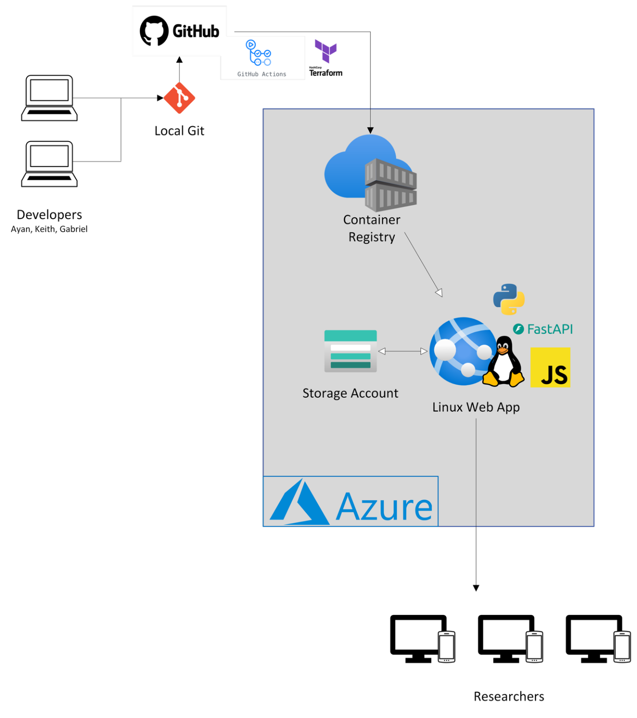

Serving System: Web Application

FastAPI Backend
The web application is built with FastAPI running on Uvicorn (ASGI server), providing:
Endpoint | Method | Purpose
/ | GET | Serves the single-page web UI (index.html)
/health | GET | Health check for Azure load balancer
/api/candidates | GET | Paginated, filterable, sortable ranked gene list
/api/genes/{gene_id} | GET | Detailed evidence breakdown for a single gene
/api/stats | GET | Pipeline summary statistics
/api/validation | GET | Known CRC biomarker validation results
/api/chat | POST | LLM-powered conversational Q&A about results
/api/reload | POST | Clear in-memory cache after pipeline re-run

Data Serving Strategy
In-memory caching: Pipeline CSV outputs are loaded into Pandas DataFrames on first request and cached in memory
Lazy loading: Data is only read from disk when first accessed, reducing startup time
Cache invalidation: POST /api/reload clears the cache, forcing a fresh read after pipeline re-runs
On-the-fly joins: Omics evidence (direction, log2FC, FDR) is merged with ranking data at query time

LLM Chat Integration
The /api/chat endpoint connects to Claude (claude-sonnet-4-20250514) with a tiered context system:
Tier 1 (always included): Static dataset summary, methodology, scoring weights, key terminology
Tier 2 (always included): Top 50 ranked candidates with full score breakdowns
Tier 3 (optional): Gene-specific detail when user is viewing a particular gene
Conversation history (last 20 messages) is maintained for context-aware follow-ups.

Web UI Features
The single-page application (web-app/static/index.html) provides:
Dashboard stats: Total genes, significant genes (FDR < 0.05), score range
Validation panel: Known CRC biomarker enrichment ratio, counts in top 500/1000/5000
Ranked candidate table: Sortable, searchable, paginated list of all ranked genes
Gene detail view: Per-gene evidence breakdown (omics, literature, pathway, LLM scores)
AI Chat: Conversational interface for exploring results with Claude
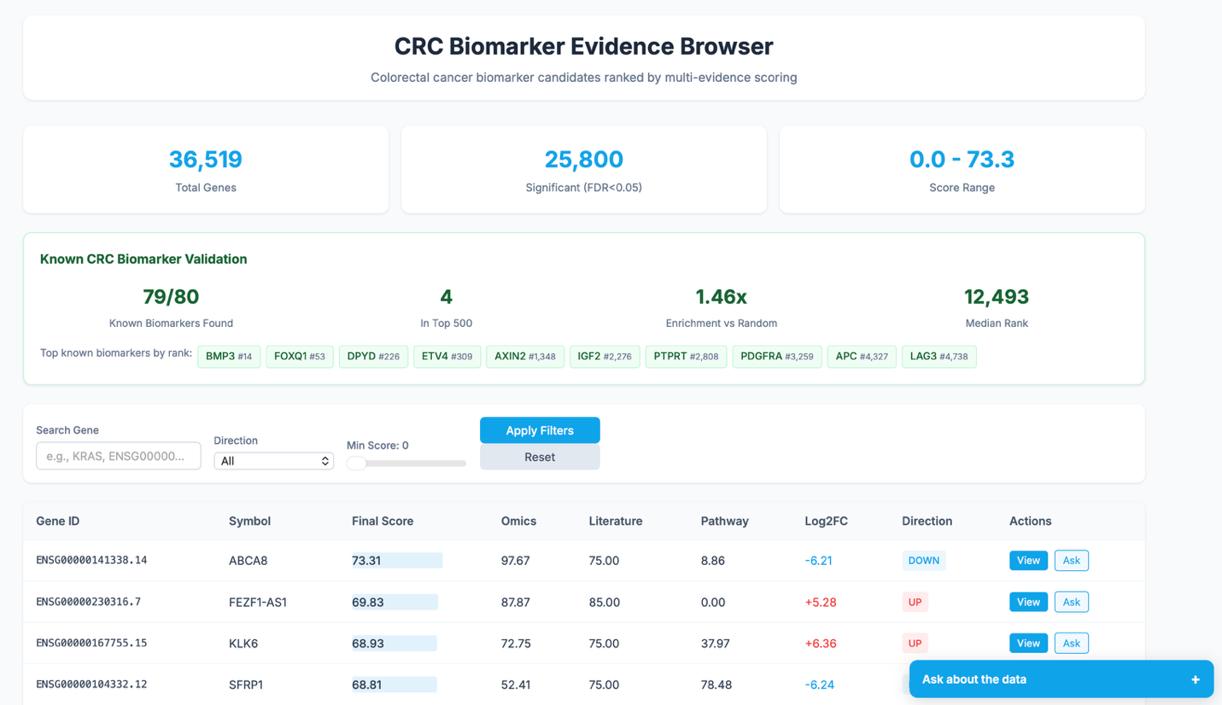
Figure 1
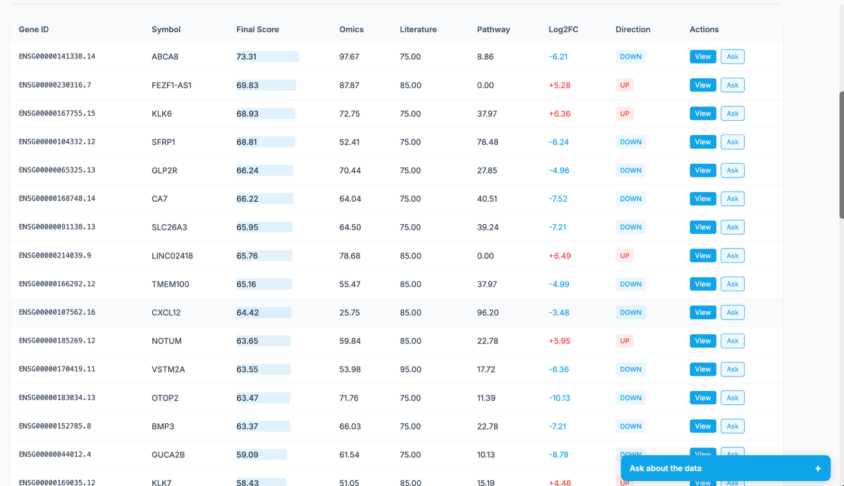
Figure 2

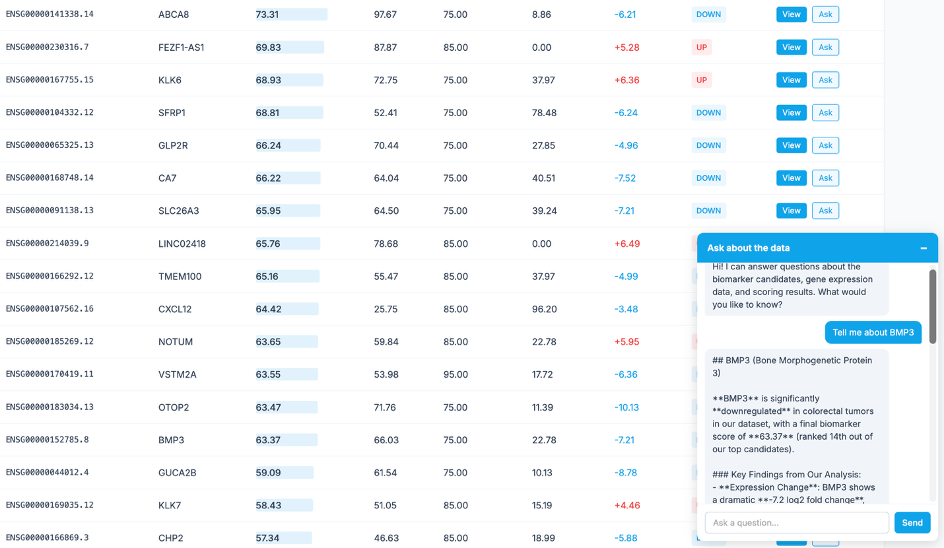
Figure 3
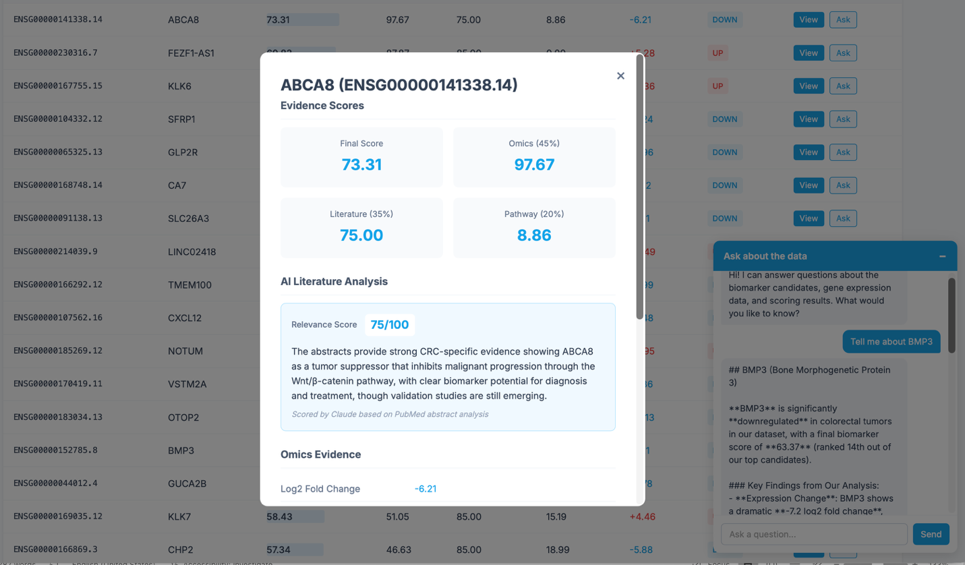
Figure 4

Pipeline Architecture
The pipeline (run_pipeline.py) executes 7 sequential steps, each implemented as an independent module:
Step | Module | Output | Description
1 | Omics Analysis (src/omics.py) | omics_evidence.csv | 36,519 genes, Welch's t-test, BH FDR
2 | ML Importance (src/ml_importance.py) | ml_importance.csv | Random Forest + SHAP, 5-fold CV
3 | PubMed Retrieval (src/pubmed.py) | lit_evidence.csv | NCBI E-Utilities, up to 5 abstracts/gene
4 | Pathway Enrichment (src/pathway.py) | pathway_evidence.csv | g:Profiler: GO:BP, KEGG, Reactome, WikiPathways
5 | LLM Scoring (src/llm_scoring.py) | llm_scores.csv + cache | Claude scores 0-100, content-hash caching
6 | Weighted Scoring (src/scoring.py) | ranked_candidates.csv | Multi-evidence combination, min-max norm
7 | Validation (src/validation.py) | validation_report.csv | 80 known CRC biomarkers, enrichment ratio

Configuration
All pipeline parameters are centralized in config/config.yaml: data paths and output directories, omics parameters (FDR threshold, candidate count), PubMed query templates and rate limits, pathway enrichment sources (GO: BP, KEGG, Reactome, WikiPathways), ML parameters (CV folds, feature count), scoring weights, and LLM model selection and caching.

Pipeline Re-execution Strategy
The modular pipeline design supports continual learning through:
1. New Data Ingestion: Replace data/TCGA-COAD.star_counts.tsv with updated counts and re-run; all downstream outputs regenerate automatically.
2. Literature Refresh: Re-run PubMed step to capture newly published abstracts; LLM cache invalidates only for genes with changed abstract content.
3. Scoring Weight Tuning: Modify weights in config/config.yaml and re-run only Steps 6-7 (scoring + validation); upstream evidence is unchanged.
4. Model Retraining: The Random Forest model retrains from scratch on each run using the latest omics data, ensuring the ML evidence stream reflects current data.

Deliverables Folder Organization
The repository is organized as follows:
AI_Capstone/
config/config.yaml Central pipeline configuration
data/TCGA-COAD.star_counts.tsv Input RNA-seq data (gitignored)
data/ensembl_to_symbol_cache.tsv Gene mapping cache
docs/ Project documentation and reports
outputs/ Pipeline output files (Steps 1-7)
src/omics.py Differential expression analysis
src/ml_importance.py Random Forest + SHAP pipeline
src/pubmed.py PubMed literature retrieval
src/pathway.py g:Profiler pathway enrichment
src/llm_scoring.py Claude-based literature scoring
src/scoring.py Weighted multi-evidence scoring
src/validation.py Known biomarker validation
src/gene_mapping.py Ensembl ID to symbol mapping
web-app/main.py FastAPI application
web-app/api/biomarkers.py REST API endpoints
web-app/api/chat.py LLM chat endpoint
web-app/static/index.html Single-page web UI
terraform/ Azure infrastructure as code
.github/workflows/deploy.yml CI/CD pipeline
Dockerfile Multi-stage container build
docker-compose.yml Local development orchestration
run_pipeline.py Pipeline CLI entrypoint
requirements.txt Python dependencies
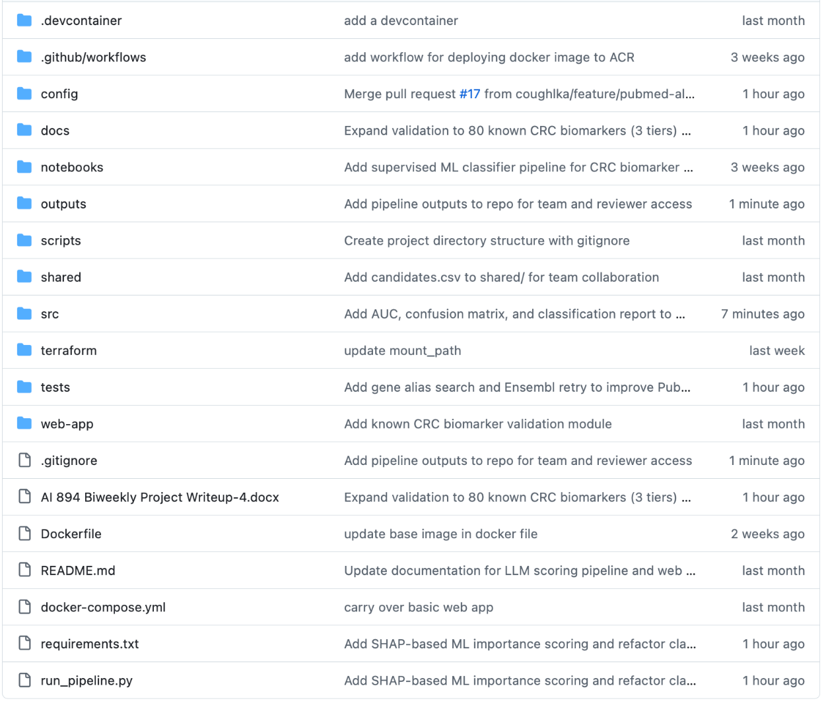
Figure 5

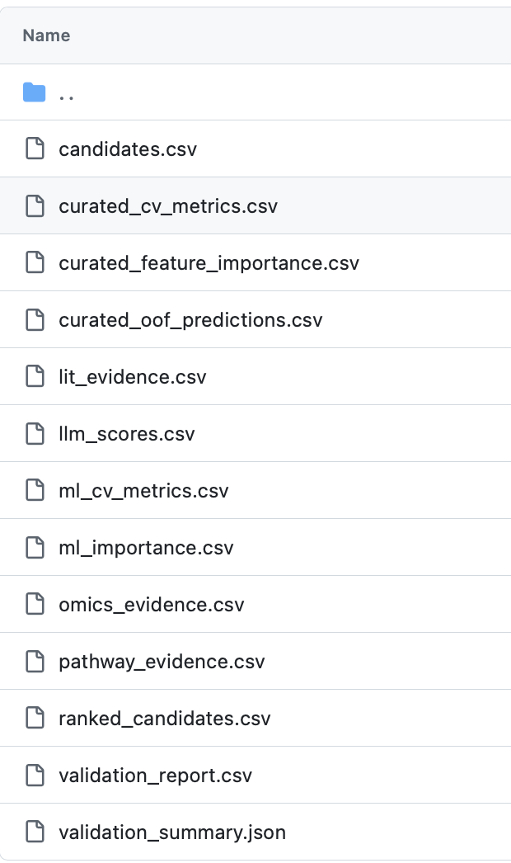
Figure 6

Installation and Execution

Running the Pipeline
git clone https://github.com/coughlka/AI_Capstone.git
cd AI_Capstone
pip install -r requirements.txt
export ANTHROPIC_API_KEY=<your-key>
python run_pipeline.py --config config/config.yaml

Running the Web Application (Local)
Option 1: Direct
cd web-app
python -m uvicorn main:app --host 0.0.0.0 --port 8000
Option 2: Docker Compose
docker-compose up
# Open http://localhost:8080

Deploying to Azure
cd terraform
terraform init
terraform plan
terraform apply
# CI/CD handles Docker build + push automatically on merge to main

Key Scripts and Notebooks Reference
File | Purpose | How to Run
run_pipeline.py | Full 7-step pipeline orchestration | python run_pipeline.py --config ...
src/omics.py | Welch's t-test DE on TCGA-COAD | Called by pipeline Step 1
src/ml_importance.py | Random Forest + SHAP importance | Called by pipeline Step 2
src/pubmed.py | PubMed abstract retrieval | Called by pipeline Step 3
src/pathway.py | g:Profiler pathway enrichment | Called by pipeline Step 4
src/llm_scoring.py | Claude-based literature scoring | Called by pipeline Step 5
src/scoring.py | Multi-evidence weighted scoring | Called by pipeline Step 6
src/validation.py | Known biomarker validation | Called by pipeline Step 7
web-app/main.py | FastAPI web application | uvicorn main:app --port 8000

Future Improvements
There are a few industry-standard improvements that can be made to this deployment model.
- Validation pipeline with unit testing, static code analysis, and security vulnerability checks. This pipeline would run each time a pull request is made. Tools like SonarQube, PyTest, and CheckMarx can provide metadata that can decorate pull requests.
- Multiple environments. Currently, we just have the production/demo environment. A real development pipeline would require a dev, qa, and production environment.
- Canary or staged deployment. Azure Web App supports staged deployments. When a new release is created, the Web App can first serve the new build to 25% of the traffic. Once the first stage is validated (no 400 errors, performance breakage, etc.), then the Web App can serve the new build to all traffic.
- Custom domain. A real production application should not use the Azure provided DNS name. We would want our own domain (*.biomarker.com). This would require us to obtain our own SSL signed certificates, which are expensive.

Lesson 12
AI cybersecurity, Ethics and Accountability

Purpose
To detail the cybersecurity controls, ethical considerations, and accountability mechanisms applied to the CRC biomarker discovery pipeline and its deployed web application.

AI Cybersecurity

Threat Model
The system has a narrow threat surface compared to a typical clinical or commercial application. It processes only public TCGA gene expression data, stores no patient-level information, and exposes a read-mostly API. The realistic threats are: leaked API credentials (Anthropic, NCBI, Azure), unauthorized access to the Azure deployment, prompt injection or abuse of the LLM chat endpoint, supply-chain compromise via third-party Python packages, and accidental commit of secrets to the public GitHub repository. The security controls described below address each of these threats directly.

Credentials and Secrets Management
All API keys and access credentials are managed outside the source code repository. The Anthropic API key required for LLM scoring and the chat endpoint is loaded from a web-app/.env file that is listed in .gitignore and never committed. The .env file is generated locally on each developer machine and on the Azure App Service via app settings, but never enters version control. A second .gitignore entry covers any *.env variants to prevent accidental commits with alternative naming.
The PubMed (NCBI E-Utilities) API key was originally hardcoded in config/config.yaml during early development. This was identified as technical debt and migrated to an environment variable in a subsequent PR. The current pipeline reads NCBI_API_KEY from the environment, falling back to unauthenticated requests with the slower rate limit (1 request per second instead of 3) if the key is not provided.
Azure credentials used by the GitHub Actions workflow are stored as encrypted GitHub Actions Secrets at the repository level. These secrets are injected into the workflow environment at build time and are never written to logs, build artifacts, or container layers. GitHub automatically masks secret values in workflow output, so even an accidental echo command would not leak them.

Network Security
The Azure deployment applies defense-in-depth network controls through a Terraform-managed virtual network. The App Service is deployed with VNet integration, routing all outbound traffic through a dedicated web subnet (10.0.1.0/24). A separate private endpoint subnet (10.0.2.0/24) hosts the private endpoint for the Azure Files storage account, which holds pipeline output artifacts.
The Azure Files storage account is configured with a private DNS zone, preventing public internet access to the file share. Even an attacker who obtained the storage account access key could not connect from outside the VNet because the storage account's public network endpoint is disabled. This was a deliberate decision to ensure pipeline outputs never traverse the public internet.
The Azure App Service itself is publicly accessible at https://psuai894webapp.azurewebsites.net, which is required for the demo and reviewer access. Azure provides automatic TLS termination with managed certificates, so all traffic to the application is encrypted in transit. There is no plaintext HTTP fallback.

Application-Level Security
The FastAPI web application applies several security controls at the application layer.
CORS: Restricted via FastAPI's CORSMiddleware to localhost origins during development. Production deployment requires explicit allowlisting of the production domain before broader use. This prevents browsers from making cross-origin requests to the API from unauthorized sites, which is the primary defense against CSRF-style attacks on the read endpoints.
Input validation: Enforced through Pydantic models at every API boundary. Query parameters are typed (int, str, Optional) with FastAPI's automatic validation rejecting malformed requests with 422 responses before they reach application logic. The chat endpoint validates the request body (ChatRequest model) for required fields and field types, preventing malformed JSON from reaching the Claude API call.
Read-only API design: Of the eight exposed endpoints, only two modify state: /api/reload (clears the in-memory cache) and /api/chat (records nothing persistently but does call the Anthropic API). All data retrieval endpoints use GET, so there is no risk of unintended writes via CSRF or accidental client behavior.
Docker security: The runtime image is built using a multi-stage Dockerfile that excludes build tools (gcc, build-essential, pip-compile) from the final image. The build stage compiles Python wheels, then the runtime stage copies only the compiled artifacts and application code. The runtime image is python:3.11-slim-bullseye with only curl added for health checks.
Local development proxy: Uses nginx with HTTP basic authentication via .htpasswd, providing a minimal access control layer when running the stack on a developer workstation. The .htpasswd file is gitignored and generated per developer.

LLM-Specific Security
The chat endpoint introduces a new class of risk because it sends user input to a third-party LLM API. Two specific concerns apply: prompt injection (a user crafts input designed to override the system prompt) and information disclosure (the model reveals information from its training data that the system is not authorized to share).
The current mitigations are partial. The system prompt provides strong context constraints, instructing Claude to discuss only the provided pipeline results, refuse questions about clinical decision-making, and decline to invent studies or biomarker claims. Conversation history is capped at the last 20 messages to limit context drift over long sessions. The Claude API call uses temperature=0 for the literature scorer and a low temperature for chat, reducing the variance of model outputs.
These mitigations do not constitute a formal prompt injection defense. An adversarial user could craft inputs designed to bypass the system prompt by inserting fake instructions or exploiting model behavior patterns. Server-side input sanitization (filtering for instruction-like patterns, length limits, and rate limiting per session) is identified as a known gap and remains in progress at the time of submission. The chat endpoint should be considered hardened against accidental misuse but not against a determined adversary.

Supply Chain Security
The pipeline depends on a moderate number of third-party Python packages declared in requirements.txt. The most security-relevant dependencies are anthropic (LLM client), fastapi (web framework), shap (SHAP value computation), scikit-learn (Random Forest), and requests (HTTP client). All dependencies are pinned to specific versions in requirements.txt to prevent silent version drift, and the Docker build uses pip's standard wheel resolution.
GitHub Dependabot is enabled on the repository and provides automatic security advisories for known CVEs in the declared dependencies. As of the final report, no critical or high-severity advisories are outstanding. Routine dependency updates are handled via PR review.
The Docker base image (python:3.11-slim-bullseye) is pulled from the official Python image on Docker Hub. The slim-bullseye variant is a Debian-based minimal image that receives regular security updates. Image rebuilds via the CI/CD pipeline pick up the latest patched base image automatically.

Known Cybersecurity Limitations
Three specific cybersecurity gaps are documented as known issues and tracked for future work:
The current system prompt and conversation history limit provide partial mitigation with server-side input sanitization with pattern-based filtering, length limits, and per-session rate limiting.

AI Ethics and Accountability

Responsible Use and Framing
The system is explicitly designed and labeled as a research decision support tool, not a clinical diagnostic. Every user-facing surface, including the web UI dashboard, API documentation, and the LLM chat system prompt, makes clear that the rankings represent computational prioritization of publicly available evidence and not clinical recommendations. No component of this system should be used to inform patient care without independent experimental validation and regulatory review.
The LLM chat system prompt explicitly instructs Claude to avoid clinical claims and to redirect users toward published literature when asked about treatment or diagnostic decisions. This guardrail is documented in web-app/api/chat.py and is applied to every conversation regardless of user input.

Data Ethics and Privacy
All data sources used by the pipeline are publicly available under established data sharing frameworks. The TCGA-COAD RNA-seq data is distributed under the TCGA Data Use Agreement governing public-access tier data. PubMed abstracts are retrieved through the official NCBI E-Utilities API within its rate limits and terms of service (3 requests per second with an API key). Pathway data is retrieved from g:Profiler under its academic use terms. No proprietary clinical datasets, restricted-access genomic data, or patient identifiers are used at any point in the pipeline.
No patient-level or personally identifiable information is processed by this system. The TCGA sample barcodes used to label samples as tumor or normal are public identifiers that do not link to individual patients in any externally identifiable way. The system processes only aggregate statistical outputs (fold change, FDR, SHAP importance, pathway enrichment) derived from the source data. The web application's API exposes only gene-level rankings and evidence scores; no sample-level data is queryable through any endpoint. TCGA data access complies with the TCGA Data Use Agreement, which does not require IRB approval because the data has been pre-aggregated and de-identified by the TCGA consortium.

Transparency and Explainability
Transparency is a core design principle of the pipeline. Every gene's final score is fully decomposable into its four component contributions (omics, ML importance, literature, pathway), each visible in the web UI gene detail view. A researcher can immediately see why a candidate was ranked highly, distinguishing genes elevated by a single strong signal from genes with convergent multi-stream evidence.
Three specific transparency mechanisms support auditability:
The LLM scoring module stores a 1-2 sentence rationale alongside each score in outputs/llm_scores.csv. When the web UI displays a gene's literature score of 75, it also displays the model's written justification, allowing users to evaluate whether the model's reasoning matches their domain expertise.
The ML evidence stream uses SHAP (SHapley Additive exPlanations) values, which are theoretically grounded in cooperative game theory and provide mathematically rigorous feature attribution. This was a deliberate replacement for an earlier supervised classifier that achieved AUC 1.0 by learning circular dependencies between features and labels. The SHAP redesign (PR #16) is documented in the repository commit history as a case study in catching and correcting an unsound modeling decision.
Scoring weights are stored in config/config.yaml and modifiable without code changes. The ablation study (src/ablation.py) provides quantitative justification for the current weight configuration by testing 246 alternatives. Users who disagree with the default weights can run their own configurations and immediately see the effect on the ranking.

Bias Considerations
The pipeline has known systematic biases that are documented in the report and the codebase rather than obscured.
Literature bias: Genes that have been heavily studied have more PubMed abstracts and consequently higher LLM scores. Novel or understudied genes with genuine biomarker potential may be disadvantaged. This bias is partially mitigated by the 40 percent omics weight, which treats all genes equally regardless of prior study, and by the gene alias retry logic in src/pubmed.py, which queries PubMed using common alternative gene names to capture literature for genes with naming inconsistencies.
Expression bias: The pipeline cannot detect mutation-driven biomarkers because these genes do not necessarily show strong differential expression. The Tier 2 (COSMIC Cancer Gene Census) validation results make this limitation visible: zero Tier 2 markers appear in the top 500 candidates and the median rank for Tier 2 markers is 9,557. This is reported transparently rather than hidden.
Cohort bias: Results are based on a single TCGA-COAD cohort, which is predominantly European-ancestry and North American. Biomarker rankings may not generalize to other populations. Multi-cohort validation against TCGA-READ and independent GEO datasets is identified as the primary future work priority.

Ethical Use of LLMs
The pipeline uses Claude in two distinct roles, each with appropriate constraints.
As a literature scorer (src/llm_scoring.py): Claude is called with temperature=0 to ensure deterministic, reproducible scores. The system prompt restricts the model to evaluating provided abstracts, with explicit instructions not to invent studies or score genes based on training-data knowledge. Each score is bounded to a 0-100 integer with a written rationale, which is stored for auditability.
As an interactive chat assistant (web-app/api/chat.py): Claude is given a tiered context including the dataset summary, top 50 candidates, and optional gene-specific detail. The system prompt instructs the model to only discuss the provided pipeline results and to refuse questions about clinical decision-making. Conversation history is limited to the last 20 messages to prevent context drift.

Version Control and Traceability
All pipeline code, configuration, and infrastructure definitions are version-controlled in the GitHub repository at https://github.com/coughlka/AI_Capstone. The team uses a feature branch workflow with pull request reviews. Notable PRs include PR #11 (Terraform deployment), PR #14 (initial supervised classifier), PR #16 (SHAP-based redesign after circularity was identified), PR #17 (PubMed alias retry), PR #18 (Docker outputs deployment fix), and PR #19 (ACR webhook).
The PR history provides a complete audit trail of every change, including the rationale for the ML approach redesign and the validation panel expansion from 33 to 80 known biomarkers. Pipeline outputs are committed to the repository at milestone points (commit 4e7d261) so reviewers can access the exact data used to generate the reported results without re-running the pipeline.
Docker images are tagged with both a rolling latest tag and an immutable git commit SHA tag (biomarker-cancer-web-app:{sha}) on every CI/CD build. This provides a complete chain of traceability from the deployed application version back to the source commit and pipeline configuration that produced the results. Rollback to any previous deployment is possible by redeploying the corresponding SHA tag.

Performance Accountability via Validation
The validation framework (80 known CRC biomarkers organized in three confidence tiers) provides a quantitative performance baseline against which all pipeline changes are evaluated. The enrichment ratio, precision, recall, and per-tier metrics serve as the primary accountability mechanism: any modification to the pipeline that does not improve or maintain these metrics requires explicit justification before merging.
This was applied directly during the ML approach redesign. When the original supervised classifier reported AUC 1.0, the team did not accept the metric at face value because the validation enrichment did not improve in proportion. The investigation revealed circular feature construction, the approach was redesigned, and BMP3 (an FDA-approved CRC biomarker) rose from rank #163 to rank #14 after the SHAP-based replacement. The lesson is documented in the commit history and the final report: high model performance metrics must be interrogated, not just optimized.
The ablation study provides a similar accountability check on the scoring weights. The current configuration produces 1.462x enrichment, while the optimal configuration found by the ablation produces 1.537x. This 0.075x difference is documented and the decision to retain the current weights is justified explicitly, rather than tuning the weights silently to maximize a single metric.

Logging and Monitoring
Each pipeline module uses Python's standard logging library to emit structured INFO and WARNING messages throughout execution. Log output includes step completion times, gene counts at each processing stage, API retry events, cache hit and miss rates, and SHAP fold-level metrics. This enables post-hoc execution tracing when diagnosing unexpected results and provides a written record of what the pipeline did during any given run.
The web application uses Uvicorn access logging and emits prefixed log messages from each API endpoint. The chat endpoint logs the user message length and the model's response token count (but not the full response content) for monitoring purposes. GitHub Actions logs every CI/CD build with full audit history, including the commit SHA, the triggering user, the build duration, and the success or failure status.

Reproducibility as Accountability
The pipeline is designed to be deterministic given identical inputs. Three specific mechanisms enforce reproducibility:
The LLM scoring module uses temperature=0 and content-hash caching (MD5 of the abstract list per gene) so that re-running the pipeline against an unchanged literature corpus produces byte-identical scores in seconds rather than 15 minutes of API calls. This prevents accidental score drift between runs and ensures that reported metrics can be exactly reproduced.
The Random Forest classifier uses random_state=42 + fold_index for each cross-validation fold, ensuring SHAP importance scores are reproducible across runs given the same input expression matrix.
The full pipeline configuration is centralized in config/config.yaml. All scoring weights, FDR thresholds, top-N selections, and API parameters live in this file. To reproduce a previous run's results exactly, a researcher needs only the source code at a specific git commit and the corresponding config file.

Team Accountability
Responsibility for each pipeline module is documented in the project README. Keith Coughlin owns the omics, ML importance, LLM scoring, scoring, and pipeline orchestration modules. Ayan Choudhury owns PubMed retrieval, the validation framework, and the MMR deficiency classifier. Gabriel Saenz owns pathway enrichment, the web application, Azure infrastructure, Terraform, and CI/CD.
Pull requests require review by at least one other team member before merging to main. Keith is the designated reviewer for Gabriel's infrastructure changes. This provides accountability for deployment decisions that affect the production Azure environment and ensures that no single team member can unilaterally change the production system.

Summary
The cybersecurity, ethics, and accountability posture of this project reflects the realistic threat model of an academic research prototype handling public data. Credentials are managed outside source control, network access to sensitive resources is restricted by VNet integration and private endpoints, application inputs are validated by typed Pydantic models, and the Docker runtime image excludes build tools to minimize attack surface.
On the ethics side, the system does not claim to solve CRC biomarker discovery; it claims to make biomarker prioritization more systematic, transparent, and auditable than the manual literature review process it supplements. Every limitation, including the expression-based bias, the literature bias toward well-studied genes, and the single-cohort validation, is documented in the report and visible in the validation results. Every modeling decision, including the ML approach redesign and the choice to retain current scoring weights despite the ablation findings, is recorded in the git history with explicit justification.
This approach trades some apparent performance for trust. The system reports a 1.46x enrichment ratio rather than tuning weights to claim a higher number; it acknowledges that mutation-driven biomarkers are invisible to expression-based analysis rather than hiding the Tier 2 results; it documents the circular classifier failure rather than quietly removing the original PR. For a research decision support tool intended for use by domain experts, transparency about limitations is more valuable than inflated performance claims.

Lesson 13
FINAL Report
- Group-Based Assignment # 8 -

Purpose:
To complete all the modules of the AI-based system

Tasks:
- Submit the final project report of your team’s Predictive Analytics system by the end of week 13. To this end, the team is supposed to complete the following:
- Prepare a new revised version of this Report.
Review this report entirely and update every chapter with consistent information that reflect the changes during the project lifecycle. Make sure that the report is well structured and reads as one single final report. All figures should be numbered, labeled, and interpreted in their sections. Introduce briefly the algorithms used and provide the formula for the evaluation metrics with their interpretations.

- Add two sections at the end of the Report with the following information:

- Discussion of results
- Discuss your results and its usefulness in solving your chosen problem.
- What will be the practical implication of your result (i.e. social/economic/commercial/scientific benefits) in society?
- What are the limitations (if any)?
- What would be the future work?
- What are the limits of your regressors or classifiers? What are your suggestions to improve them in the future?

- Individual feedback (one paragraph per student)
- Feel free to share your feedback and thoughts about the final project terms and provide your positive feedback and suggestions to improve this project objectives.
- …

- The team should set up an appointment with me to discuss about the project report feedback before the final project report submission. The team meeting has to be scheduled as early as Friday and no later than Sunday.
- More instructions about the final submission of the project report, datasets, scripts etc. will be provided by the instructor over the e-mail.

- Update the previous assignment content (aka GROUP-BASED ASSIGNMENT # ) with the comments and suggestions provided by your instructor.
- Keep this Write up document up-to-date and coherent with your project progress.

- Make sure that your technical and technological survey are updated, considering the knowledge you acquire during this project and the evolution of your project objectives and deliverables (you should confirm that your project proposal is updated).

Lesson 14
Project Presentataion & DEMO
- Group-Based Assignment # 9 -

Purpose:
To provide a demonstration of your team’s Predictive Analytics System
Tasks:
- The team should prepare a demo to demonstrate the designed Predictive Analytics System that you have developed with your team in this capstone course.
- The demonstration could be video recorded and shared with the instructor through the box/Canvas.
- Every team will have an opportunity to go through the demonstration of the Predictive Analytics system designed by different teams. I will share the video recording from different teams using the box.
- The team should set up an appointment with me to discuss about the feedback on the project report and on the demonstration video in this week, one day after the final submission is done.
- Team members should submit the peer evaluation form latest by Thursday 11:59 PM EST in week 14.
- More instructions will be provided by the instructor over the e-mail.
- Please give your feedback on SRTE survey. Your opinion and feedback are valuable and help to improve this course.

Appendices

Appendix A: Scoring Weight Configuration
Current weights in config/config.yaml:
scoring:
weights:
omics: 0.40
ml_importance: 0.10
literature: 0.30
pathway: 0.20
These weights were selected based on domain expertise and validated against the 33 known CRC biomarker panel. The omics stream receives the highest weight as differential expression provides the most direct molecular evidence. Literature receives the second-highest weight as published research contextualizes the biological relevance. Pathway enrichment captures systems-level evidence. ML importance provides a data-driven complement to the hypothesis-driven omics score.

Appendix B: LLM Scoring Rubric
The Claude model scores each gene's literature evidence on a 0-100 scale:
Range | Interpretation
80-100 | Direct, established CRC biomarker with clear clinical utility
60-79 | Strong CRC evidence, emerging or not yet clinically validated
40-59 | CRC mentioned but not primary focus; indirect evidence
20-39 | Tangential CRC relevance only
0-19 | No meaningful CRC biomarker evidence

Criteria weights: Direct CRC evidence (40%), Biomarker potential (30%), Mechanistic insight (20%), Evidence quality (10%).

Appendix C: Validation Biomarker Panel (80 markers, 3 tiers)
Tier 1 - FDA/Guideline (14): KRAS, NRAS, BRAF, EGFR, ERBB2, MLH1, MSH2, MSH6, PMS2, EPCAM, VEGFA, BMP3, NDRG4, DPYD
Tier 2 - COSMIC CGC (25): APC, TP53, PIK3CA, SMAD4, FBXW7, PTEN, CTNNB1, RNF43, POLE, TGFBR2, AXIN2, SOX9, TCF7L2, AMER1, ARID1A, SMAD2, ACVR2A, ATM, ZNRF3, BCL9L, RBM10, PCBP1, RPL22, PTPRT, FAM123B
Tier 3 - Validated Literature (41): VIM, CDH1, CEACAM5, MKI67, CDX2, DCC, MYC, MSH3, ERBB3, MET, VEGFB, FLT1, KDR, PDGFRA, IGF2, MAP2K1, TGFB1, SMAD3, NOTCH1, JAG1, DLL4, GSK3B, CSNK1A1, DVL2, MYB, ETV4, FOXQ1, CD274, PDCD1, CTLA4, LAG3, DNMT1, DNMT3B, TET2, KDM6A, MUTYH, CHEK2, BRCA1, BRCA2, PALB2, PIK3R1
Functional Categories: mutation/tumor-suppressor (27), signaling/pathway (31), MMR/MSI (6), expression/methylation (8), immune-checkpoint (4), epigenetic (4), pharmacogenomic (1)

Appendix D: Works Cited
Ali, I. (2024). AI Transparency and Explainability. Conference: Seminar TalkAt: Frankfurt
University of Applied Sciences.
AWS. (n.d.). AWS. Retrieved from What is Infrastructure as Code?: https://aws.amazon.com/what-is/iac/#:~:text=Infrastructure%20as%20code%20(IaC)%20is,of%20manual%20processes%20and%20settings.
Demner-Fushman, D., Chapman, W. W., & McDonald, C. J. (2009). What can natural language processing do for clinical decision support? National Library of Medicine, 42(5), 760-772. Retrieved from National Library of Medicine: https://pubmed.ncbi.nlm.nih.gov/19683066/
Doshi-Velez, F., & Kim, B. (2017, March 2). Towards A Rigorous Science of Interpretable Machine Learning. Retrieved January 2026, from arXiv: https://arxiv.org/abs/1702.08608
Liang, S., & Sonntag, D. (2025, August). Advancing Biomedical Claim Verification by Using Large Language Models with Better Structured Prompting Strategies. (pp. 148-166). Viena: Association for Computational Linguistics.
Liu, H., Song, C., & Wang, J. (2024). Development of fecal microbial diagnostic marker sets of colorectal cancer using natural language processing method. The International Journal of Biological Markers, 39(1), 31-39.
Mahmoud, A. (2025). Explainable AI for Prognostic Factor Identification in Colorectal Cancer: An Electronic Health Records Analysis. International Journal of Mathematics, Statistics, and Computer Science, 3, 457-475.
Mahmoud, A., & Takaoka, E. (2025). An enhanced machine learning approach with stacking ensemble learner for accurate liver cancer diagnosis using feature selection and gene expression data. Healthcare Analytics, 7.
Marx, O. (2024, July 25). Transcriptomic characterization of early-onset colorectal cancer. Retrieved from PennState University Libraries Electronic Theses and Dissertations for Graduate School: https://etda.libraries.psu.edu/catalog/19361omm5177
Novielli, P., Romano, D., & Magarelli, M. (2024, February). Explainable artificial intelligence for microbiome data analysis in colorectal cancer biomarker identification. Frontiers In Microbology, 15.
Sung, H., Ferlay, J., & Siegel, R. (2021). Global Cancer Statistics 2020: GLOBOCAN Estimates of Incidence and Mortality Worldwide for 36 Cancers in 185 Coutries. CA Cancer J Clin., 71, 209-249.

